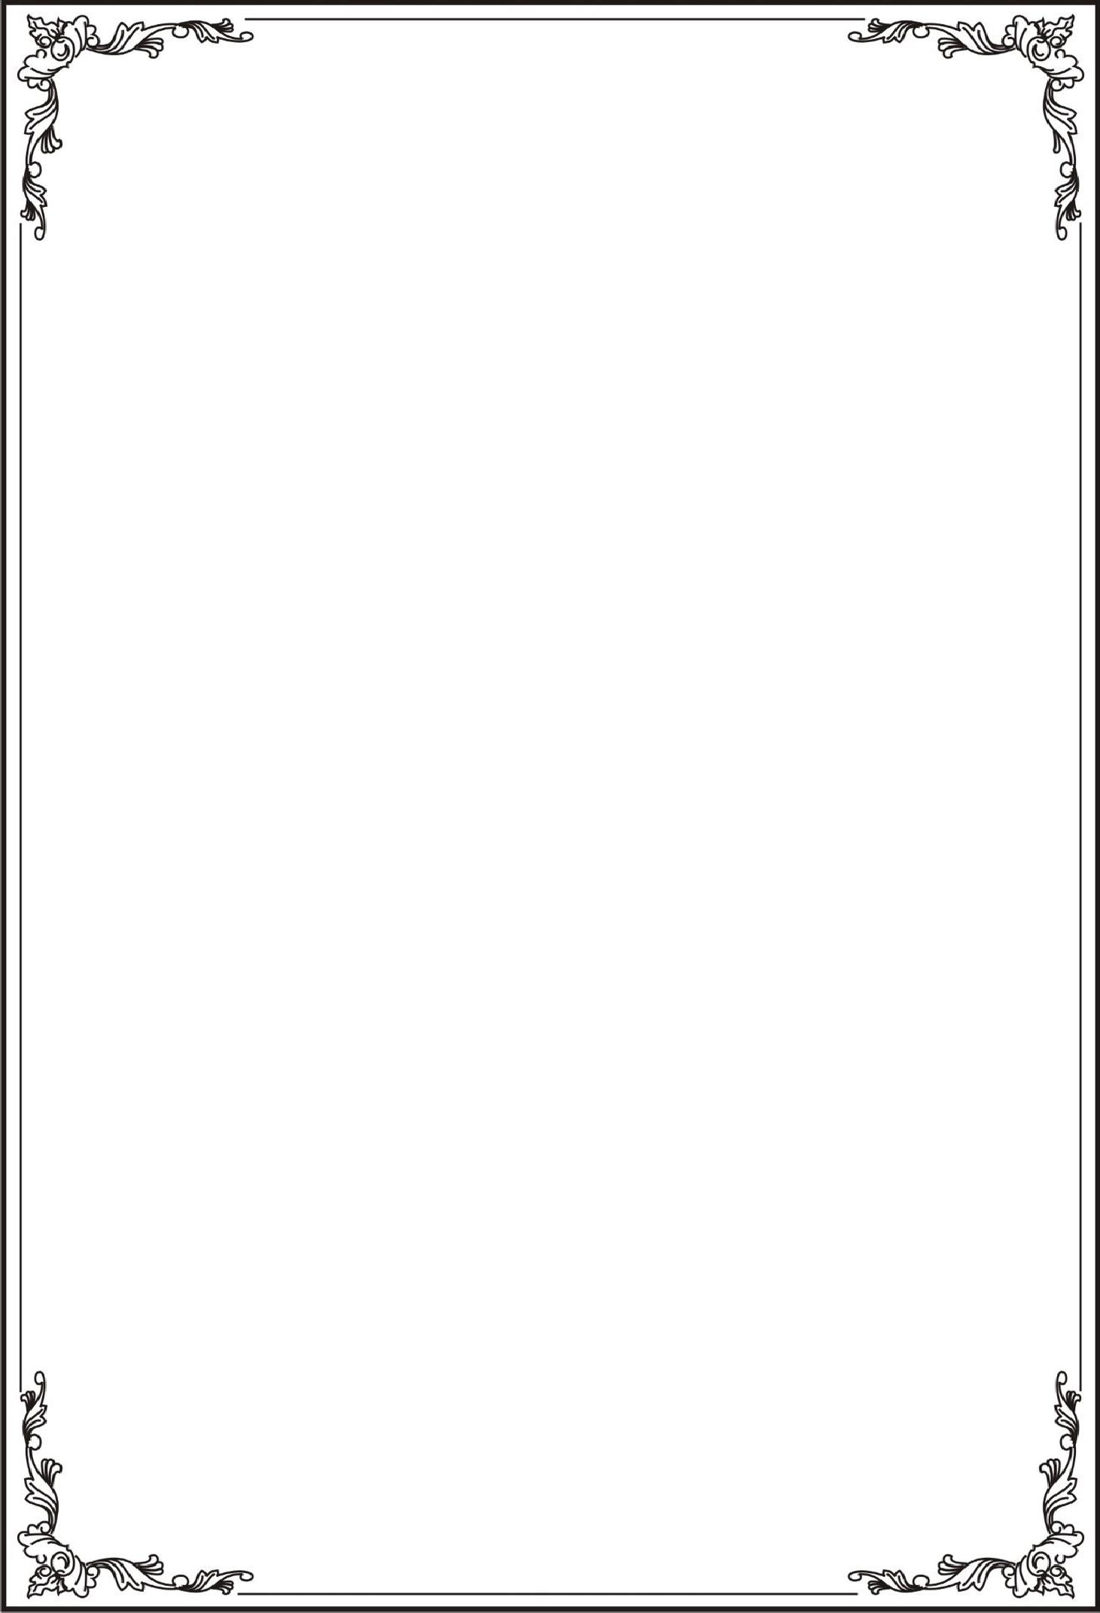

TRƯỜNG ĐẠI HỌC TÀI NGUYÊN VÀ MÔI TRƯỜNG

THÀNH PHỐ HỒ CHÍ MINH

KHOA CÔNG NGHỆ THÔNG TIN



TỔNG HỢP LAB LẬP TRÌNH DI ĐỘNG

Lớp:11_ĐH_THMT

Họ tên Mã số sinh viên

Võ Huỳnh Phúc Huy 1150080055

Năm học**:** 2025-2026

Giảng viên: ThS. Phạm Trọng Huynh

TP. Hồ Chí Minh, tháng 12 năm 2024

TRƯỜNG ĐẠI HỌC TÀI NGUYÊN VÀ MÔI TRƯỜNG

THÀNH PHỐ HỒ CHÍ MINH

KHOA CÔNG NGHỆ THÔNG TIN



TỔNG HỢP LAB LẬP TRÌNH DI ĐỘNG

Lớp:11_ĐH_THMT

Họ tên Mã số sinh viên

Võ Huỳnh Phúc Huy 1150080055

Năm học**:** 2025-2026

Giảng viên: ThS. Phạm Trọng Huynh

TP. Hồ Chí Minh, tháng 12 năm 2024

Mục Lục

Lab1: 5

Lab1: 5

Bài 1:Hoàn thiện các chức năng của một máy tính, có các phép +, -, *, /, 5

Bài 2:Xây dựng ứng dụng xúc sắc 11

Bài 3:Viết chương trình cho phép gọi, nhắn tin trên Hệ điều hành Android. 15

**Lab2:** 22

Bài 1: viết code để mỗi khi chạy lên sẽ ra một màu nền khác nhau 22

Bài 2: sử dụng Custom ProgressBar để làm giao diện đẹp hơn. 24s

Bài 3: Lập trình để khi bấm vào icon thì chuyển về cuộc gọi, sử dụng Intent. 25

Bài 4: Tạo màn hình chính MainActivity để chuyển qua và chuyển về giữa các màn hình 35

Lab2 39

**Lab3** 39

Bài 1: Xây dựng ứng dụng Truyện Cười (P1) 39

Bài 2: Sử dụng các kiến thức đã giới thiệu ở phần đa ngữ ở trên, thiết kế chương trình 43

Lab4 48

Bài 1 tạo login 50

Bài 2: Tạo giao diện menu 54

Bài 3: Tạo giao diện Toast Emoij 58

Lab5 64

Bài 1: Xử lý animation trong layout 64

Lab3 66

Lab6: 66

Bài 1:Chuyển đổi đơn vị tiền tệ: 66

**Lab7:** 74

Bài 1: Sử dụng Custom Button, thiết kế giao diện 74

Bài 2: dựa trên bài 1 làm các animation cho các ảnh, tạo ra 1 giao diện đăng nhập cơ bản 79

Bài 3: tạo các 1 layout chỉnh các màu theo giao diện đã cho 88

Lab8: 91

Bài 1 & 2: Sử dụng Custom Listview, Custom GridView, 91

Bài 3:Thêm tính năng, thêm xóa sửa 100

Lab4 103

Lab10:truyện vui dân gian 103

Lab5 126

Bài 13 & 14 Ứng dụng đăng nhập và đăng ký 126

# Lab1:

## Lab1:

### Bài 1:Hoàn thiện các chức năng của một máy tính, có các phép +, -, *, /,

B1:sửa file activity_main.xml

<LinearLayout  
 xmlns:android="http://schemas.android.com/apk/res/android"  
 xmlns:app="http://schemas.android.com/apk/res-auto"  
 xmlns:tools="http://schemas.android.com/tools"  
 android:layout_width="match_parent"  
 android:layout_height="match_parent"  
 android:orientation="vertical"  
 android:weightSum="10"  
 tools:context=".MainActivity">  
  
 <EditText  
 android:id="@+id/txtX"  
 android:gravity="center"  
 android:layout_width="match_parent"  
 android:layout_weight="1"  
 android:layout_height="0dp"/>  
  
 <EditText  
 android:id="@+id/txtY"  
 android:gravity="center"  
 android:layout_width="match_parent"  
 android:layout_weight="1"  
 android:layout_height="0dp"/>  
  
 <TextView  
 android:id="@+id/txtResult"  
 android:layout_width="match_parent"  
 android:layout_height="0dp"  
 android:layout_weight="1"  
 android:gravity="center"  
 android:text="@string/result" />  
  
  
 <LinearLayout  
 android:layout_width="match_parent"  
 android:layout_height="0dp"  
 android:layout_weight="1"  
 android:orientation="horizontal"  
 android:weightSum="5">  
  
 <Button  
 android:id="@+id/btnPlus"  
 android:layout_width="0dp"  
 android:layout_weight="1"  
 android:text="@string/plus"  
 android:layout_height="match_parent"/>  
 <Button  
 android:id="@+id/btnMinus"  
 android:layout_width="0dp"  
 android:layout_weight="1"  
 android:text="@string/minus"  
 android:layout_height="match_parent"/>  
  
 <Button  
 android:id="@+id/btnMultiply"  
 android:layout_width="0dp"  
 android:layout_weight="1"  
 android:text="@string/multiply"  
 android:layout_height="match_parent"/>  
  
 <Button  
 android:id="@+id/btnDivide"  
 android:layout_width="0dp"  
 android:layout_weight="1"  
 android:text="@string/divide"  
 android:layout_height="match_parent"/>  
  
 <Button  
 android:id="@+id/btnModulo"  
 android:layout_width="0dp"  
 android:layout_weight="1"  
 android:text="@string/modulo"  
 android:layout_height="match_parent"/>  
 </LinearLayout>  
  
</LinearLayout>

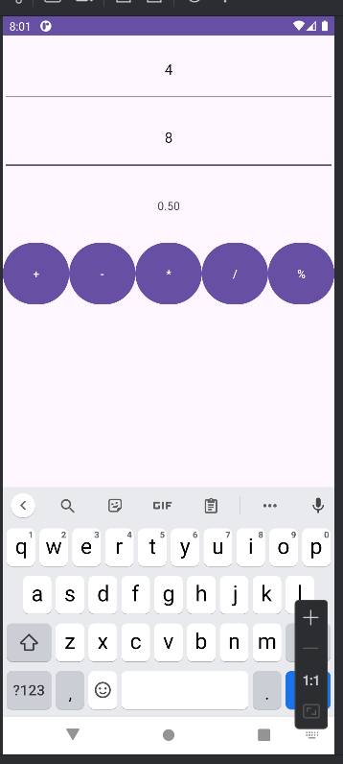

**Sửa file String.xml như sau:**

<resources>  
 <string name="app_name">Caculator</string>  
 <string name="from_xml">From Xml</string>  
 <string name="from_code">From CODE</string>  
 <string name="fade_in">Fade In</string>  
 <string name="fade_out">Fade Out</string>  
 <string name="blink">Blink</string>  
 <string name="zoom_in">Zoom In</string>  
 <string name="zoom_out">Zoom Out</string>  
 <string name="rotate">Rotate</string>  
 <string name="move">Move</string>  
 <string name="slide_up">Slide Up</string>  
 <string name="bounce">Bounce</string>  
 <string name="combine">Combine</string>  
 <string name="status_playing">Playing....</string>  
 <string name="result">Result</string>  
 <string name="plus">+</string>  
 <string name="minus">-</string>  
 <string name="multiply">*</string>  
 <string name="divide">/</string>  
 <string name="equal">+</string>  
 <string name="modulo">%</string>  
</resources>

**Sau đó ta viết các hàm để thực hiện các phép tính ở file Mainactivity.java**

package com.example.firstprogram;  
  
import android.os.Bundle;  
import android.view.View;  
import android.widget.Button;  
import android.widget.EditText;  
import android.widget.TextView;  
import android.widget.Toast;  
import androidx.appcompat.app.AppCompatActivity;  
  
public class MainActivity extends AppCompatActivity {  
  
 EditText txtX, txtY;  
 TextView txtResult;  
 Button btnPlus, btnMinus, btnMultiply, btnDivide, btnModulo;  
  
 @Override  
 protected void onCreate(Bundle savedInstanceState) {  
 super.onCreate(savedInstanceState);  
 setContentView(R.layout.*activity_main*);  
 initControl();  
 }  
  
 private void initControl() {  
 txtX = findViewById(R.id.*txtX*);  
 txtY = findViewById(R.id.*txtY*);  
 txtResult = findViewById(R.id.*txtResult*);  
 btnPlus = findViewById(R.id.*btnPlus*);  
 btnMinus = findViewById(R.id.*btnMinus*);  
 btnMultiply = findViewById(R.id.*btnMultiply*);  
 btnDivide = findViewById(R.id.*btnDivide*);  
 btnModulo = findViewById(R.id.*btnModulo*);  
  
   
 btnPlus.setOnClickListener(v -> performOperation('+'));  
 btnMinus.setOnClickListener(v -> performOperation('-'));  
 btnMultiply.setOnClickListener(v -> performOperation('*'));  
 btnDivide.setOnClickListener(v -> performOperation('/'));  
 btnModulo.setOnClickListener(v -> performOperation('%'));  
 }  
  
 private void performOperation(char operator) {  
 try {  
 String xStr = txtX.getText().toString();  
 String yStr = txtY.getText().toString();  
  
  
 if (xStr.isEmpty() || yStr.isEmpty()) {  
 Toast.*makeText*(this, "Please enter both X and Y", Toast.*LENGTH_SHORT*).show();  
 return;  
 }  
  
 double x = Double.*parseDouble*(xStr);  
 double y = Double.*parseDouble*(yStr);  
 double result = 0;  
  
 switch (operator) {  
 case '+':  
 result = x + y;  
 break;  
 case '-':  
 result = x - y;  
 break;  
 case '*':  
 result = x * y;  
 break;  
 case '/':  
 if (y == 0) {  
  
 Toast.*makeText*(this, "Cannot divide by zero", Toast.*LENGTH_SHORT*).show();  
 return;  
 }  
 result = x / y;   
 break;   
  
  
 case '%':  
 if (y == 0) {  
 Toast.*makeText*(this, "Cannot modulo by zero", Toast.*LENGTH_SHORT*).show();  
 return;  
 }  
 result = x % y;  
 break;  
 }  
  
  
 txtResult.setText(String.*format*("%.2f", result));  
  
 } catch (NumberFormatException e) {  
   
 Toast.*makeText*(this, "Invalid input. Please enter numbers.", Toast.*LENGTH_SHORT*).show();  
 }  
 }  
}

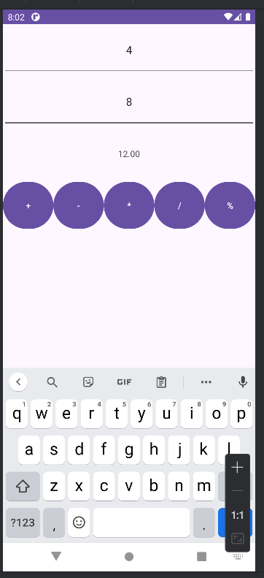

### Bài 2:Xây dựng ứng dụng xúc sắc

**Xây dựng một ứng dụng cho phép mỗi khi người dùng nhấn nút thì xuất một số  ngẫu nhiên ra màn hình (trái). Cải tiến để minh họa tung khối xúc xắc 6 mặt như hình phải.**

**Đầu tiên ta tạo 1 file java với tên DiceActivity, sau đó vào AndroidMainfest để thay đổi activity**

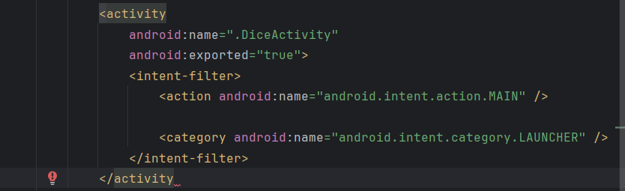

**File DiceActivity.java**

package com.example.firstprogram;  
  
import android.os.Bundle;  
import android.view.View;  
import android.widget.Button;  
import android.widget.ImageView;  
import android.widget.TextView;  
import androidx.appcompat.app.AppCompatActivity;  
import java.util.Random;  
  
public class DiceActivity extends AppCompatActivity {  
  
  
 TextView txtNumber;  
 ImageView imgDice;  
 Button btnRoll;  
 Random random = new Random();  
  
 @Override  
 protected void onCreate(Bundle savedInstanceState) {  
 super.onCreate(savedInstanceState);  
 setContentView(R.layout.*activity_dice*);  
  
   
 txtNumber = findViewById(R.id.*txtNumber*);  
 imgDice = findViewById(R.id.*imgDice*);  
 btnRoll = findViewById(R.id.*btnRoll*);  
  
 btnRoll.setOnClickListener(new View.OnClickListener() {  
 @Override  
 public void onClick(View v) {  
  
 int number = random.nextInt(6) + 1;  
 txtNumber.setText("Number: " + number);  
  
 int diceImage = R.drawable.*so1*;   
 switch (number) {  
 case 1:  
 diceImage = R.drawable.*so1*;  
 break;  
 case 2:  
 diceImage = R.drawable.*so2*;  
 break;  
 case 3:  
 diceImage = R.drawable.*so3*;  
 break;  
 case 4:  
 diceImage = R.drawable.*so4*;  
 break;  
 case 5:  
 diceImage = R.drawable.*so5*;  
 break;  
 case 6:  
 diceImage = R.drawable.*so6*;  
 break;  
 default:  
 diceImage = R.drawable.*so1*;  
 break;  
 }  
 imgDice.setImageResource(diceImage);  
 }  
 });  
 }  
}

sau đó ta tạo file activity_dice.xml

<?xml version="1.0" encoding="utf-8"?>  
<LinearLayout xmlns:android="http://schemas.android.com/apk/res/android"  
 android:layout_width="match_parent"  
 android:layout_height="match_parent"  
 android:orientation="vertical"  
 android:gravity="center"  
 android:padding="16dp">  
  
 <TextView  
 android:id="@+id/txtNumber"  
 android:layout_width="wrap_content"  
 android:layout_height="wrap_content"  
 android:text="Number: -"  
 android:textSize="24sp"  
 android:layout_marginBottom="16dp" />  
  
 <ImageView  
 android:id="@+id/imgDice"  
 android:layout_width="100dp"  
 android:layout_height="100dp"  
 android:layout_marginBottom="16dp" />  
  
 <Button  
 android:id="@+id/btnRoll"  
 android:layout_width="wrap_content"  
 android:layout_height="wrap_content"  
 android:text="Roll Dice" />  
  
</LinearLayout>

**Ta tìm kiếm 6 ảnh của 6 ảnh xúc xắc để thêm vào thư mục drawtable(lưu ý đặt tên file bằng chữ thường không được in hoa)**

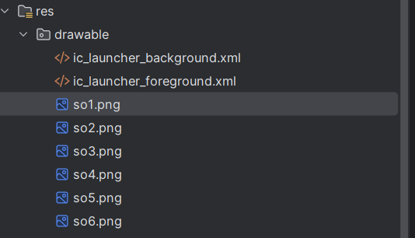

**Sản phẩm thì ta có như sau**

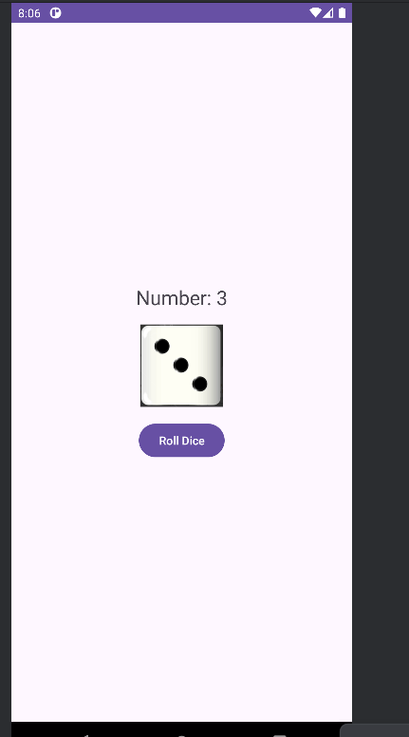

### Bài 3:Viết chương trình cho phép gọi, nhắn tin trên Hệ điều hành Android.

**Đầu tiên ta tạo 1 file java với tên PhoneActivity, sau đó vào AndroidMainfest để thay đổi activity**

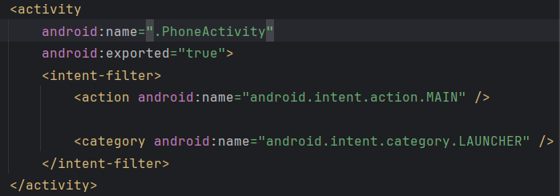

Thêm 3 dòng này ở file Androidmainfest trước thẻ application

<uses-permission android:name="android.permission.CALL_PHONE" />  
<uses-permission android:name="android.permission.SEND_SMS" />  
<uses-feature android:name="android.hardware.telephony" android:required="false" />

**Code file PhoneActivity**

package com.example.firstprogram;  
  
  
import android.content.pm.PackageManager;  
import android.net.Uri;  
import android.os.Bundle;  
import android.telephony.SmsManager;  
import android.widget.Button;  
import android.widget.EditText;  
import android.widget.Toast;  
import androidx.appcompat.app.AppCompatActivity;  
import androidx.core.app.ActivityCompat;  
import androidx.core.content.ContextCompat;  
import android.content.Intent;  
import android.view.View;  
  
public class PhoneActivity extends AppCompatActivity {  
  
  
 EditText txtPhone;  
 Button btnCall, btnSendSMS;  
 private static final int *REQUEST_CALL_PHONE* = 1;  
 private static final int *REQUEST_SEND_SMS* = 2;  
  
 @Override  
 protected void onCreate(Bundle savedInstanceState) {  
 super.onCreate(savedInstanceState);  
 setContentView(R.layout.*activity_phone*);  
  
   
 txtPhone = findViewById(R.id.*txtPhone*);  
 btnCall = findViewById(R.id.*btnCall*);  
 btnSendSMS = findViewById(R.id.*btnSendSMS*);  
 btnCall.setOnClickListener(new View.OnClickListener() {  
 @Override  
 public void onClick(View v) {  
 makePhoneCall();  
 }  
 });  
  
 btnSendSMS.setOnClickListener(new View.OnClickListener() {  
 @Override  
 public void onClick(View v) {  
 sendSMS();  
 }  
 });  
 }  
 private void makePhoneCall() {  
 String phoneNumber = txtPhone.getText().toString().trim();  
 if (phoneNumber.isEmpty()) {  
 Toast.*makeText*(this, "Please enter a phone number", Toast.*LENGTH_SHORT*).show();  
 return;  
 }  
  
 if (ContextCompat.*checkSelfPermission*(this, android.Manifest.permission.*CALL_PHONE*)  
 != PackageManager.*PERMISSION_GRANTED*) {  
 ActivityCompat.*requestPermissions*(this,  
 new String[]{android.Manifest.permission.*CALL_PHONE*}, *REQUEST_CALL_PHONE*);  
 } else {  
 Intent callIntent = new Intent(Intent.*ACTION_CALL*);  
 callIntent.setData(Uri.*parse*("tel:" + phoneNumber));  
 startActivity(callIntent);  
 }  
 }  
  
 private void sendSMS() {  
 String phoneNumber = txtPhone.getText().toString().trim();  
 if (phoneNumber.isEmpty()) {  
 Toast.*makeText*(this, "Please enter a phone number", Toast.*LENGTH_SHORT*).show();  
 return;  
 }  
  
 if (ContextCompat.*checkSelfPermission*(this, android.Manifest.permission.*SEND_SMS*)  
 != PackageManager.*PERMISSION_GRANTED*) {  
 ActivityCompat.*requestPermissions*(this,  
 new String[]{android.Manifest.permission.*SEND_SMS*}, *REQUEST_SEND_SMS*);  
 } else {  
 try {  
 SmsManager smsManager = SmsManager.*getDefault*();  
 smsManager.sendTextMessage(phoneNumber, null, "Hello from Lab1!", null, null);  
 Toast.*makeText*(this, "SMS sent", Toast.*LENGTH_SHORT*).show();  
 } catch (Exception e) {  
 Toast.*makeText*(this, "Failed to send SMS", Toast.*LENGTH_SHORT*).show();  
 }  
 }  
 }  
  
  
 @Override  
 public void onRequestPermissionsResult(int requestCode, String[] permissions, int[] grantResults) {  
 super.onRequestPermissionsResult(requestCode, permissions, grantResults);  
 if (requestCode == *REQUEST_CALL_PHONE*) {  
 if (grantResults.length > 0 && grantResults[0] == PackageManager.*PERMISSION_GRANTED*) {  
 makePhoneCall();  
 } else {  
 Toast.*makeText*(this, "Call permission denied", Toast.*LENGTH_SHORT*).show();  
 }  
 } else if (requestCode == *REQUEST_SEND_SMS*) {  
 if (grantResults.length > 0 && grantResults[0] == PackageManager.*PERMISSION_GRANTED*) {  
 sendSMS();  
 } else {  
 Toast.*makeText*(this, "Send SMS permission denied", Toast.*LENGTH_SHORT*).show();  
 }  
 }  
 }  
}

**file activity_phone_xml**

<?xml version="1.0" encoding="utf-8"?>  
<LinearLayout xmlns:android="http://schemas.android.com/apk/res/android"  
 android:layout_width="match_parent"  
 android:layout_height="match_parent"  
 android:orientation="vertical"  
 android:padding="16dp">  
  
 <EditText  
 android:id="@+id/txtPhone"  
 android:layout_width="match_parent"  
 android:layout_height="wrap_content"  
 android:hint="Enter phone number"  
 android:inputType="phone" />  
  
 <Button  
 android:id="@+id/btnCall"  
 android:layout_width="match_parent"  
 android:layout_height="wrap_content"  
 android:text="Call" />  
  
 <Button  
 android:id="@+id/btnSendSMS"  
 android:layout_width="match_parent"  
 android:layout_height="wrap_content"  
 android:text="Send SMS" />  
  
</LinearLayout>

Sau khi mở:

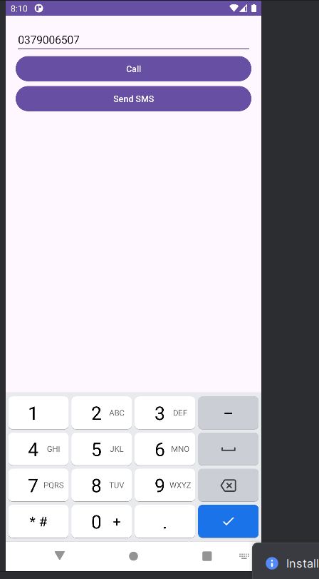

Khi ta gọi thành công:

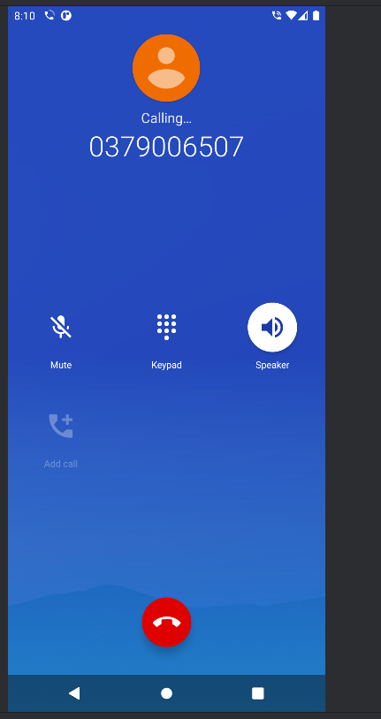

Gửi tin nhắn thành công:

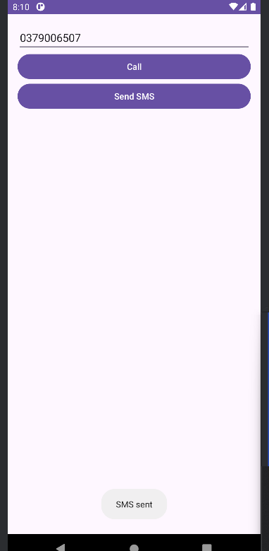

## **Lab2:**

### Bài 1: viết code để mỗi khi chạy lên sẽ ra một màu nền khác nhau

và 1 icon khác nhau.

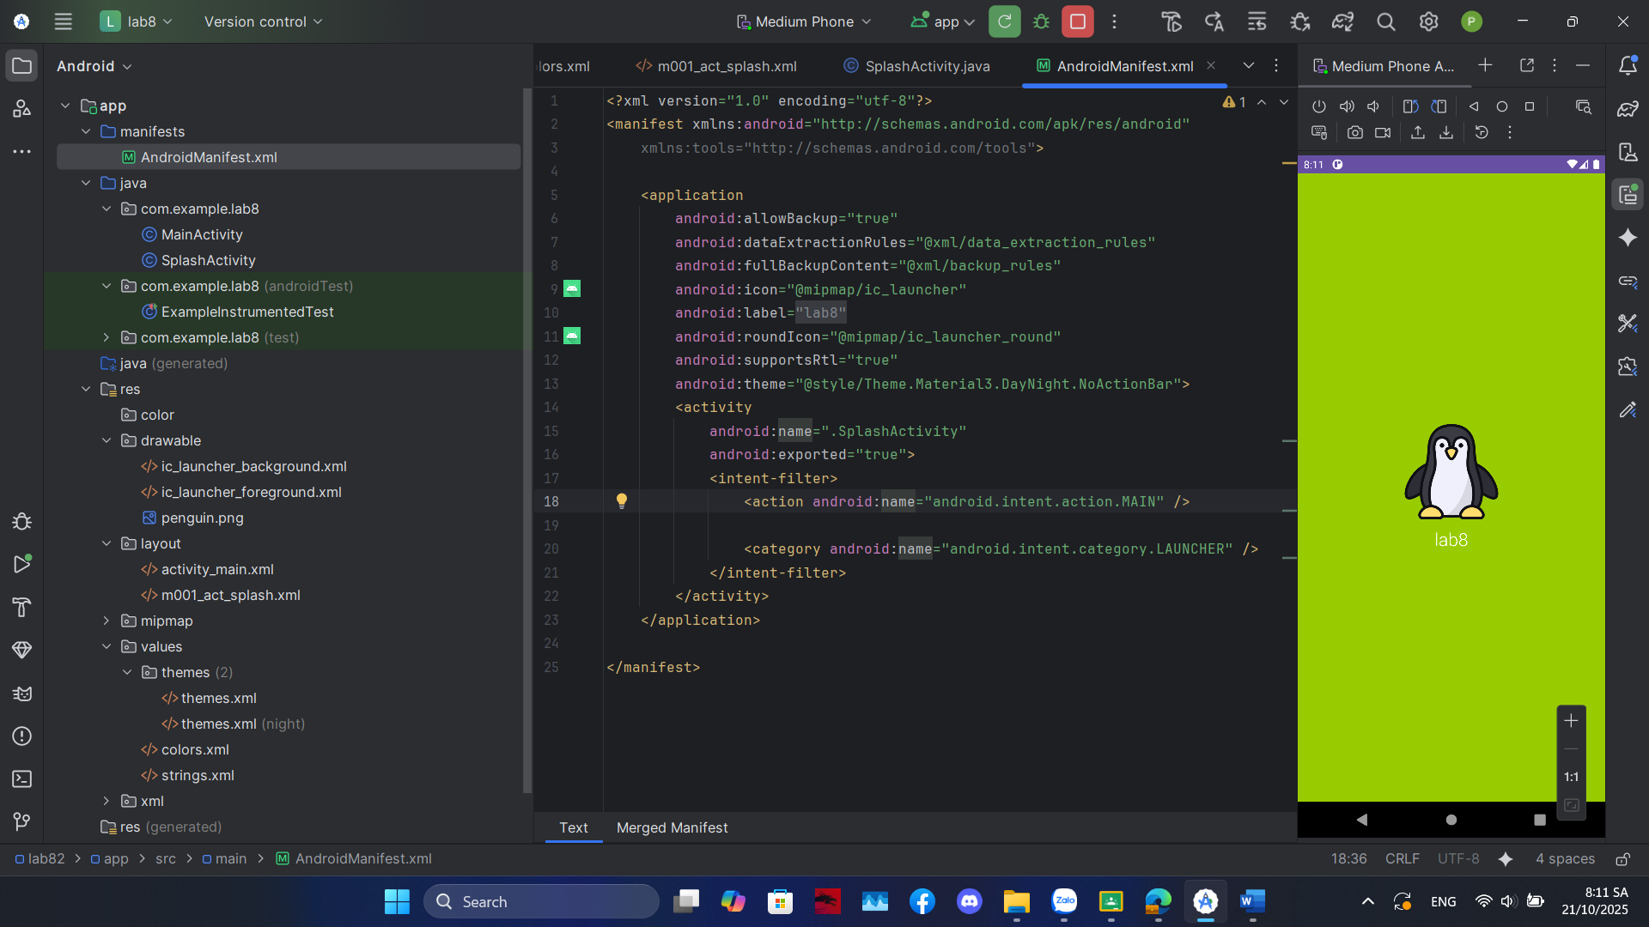

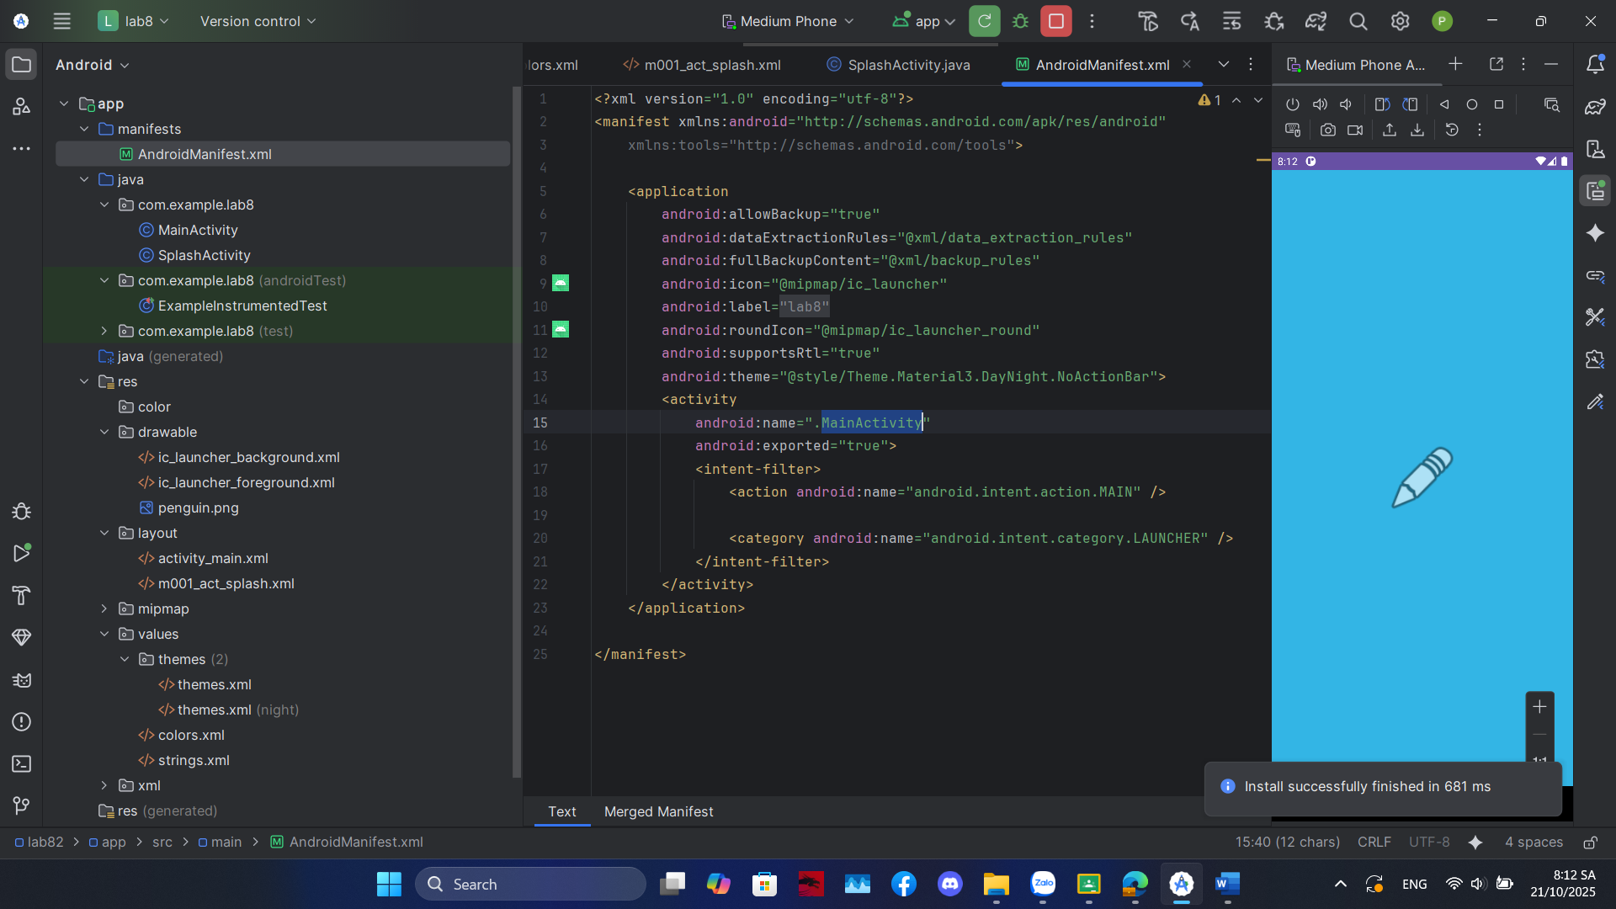

**m001_act_splash**

<?xml version="1.0" encoding="utf-8"?>  
<LinearLayout xmlns:android="http://schemas.android.com/apk/res/android"  
 xmlns:tools="http://schemas.android.com/tools"  
 android:id="@+id/splashLayout"  
 android:layout_width="match_parent"  
 android:layout_height="match_parent"  
 android:gravity="center"  
 android:orientation="vertical"  
 tools:context=".SplashActivity"  
 tools:background="@color/design_default_color_primary_dark">  
 <ImageView  
 android:id="@+id/splashIcon"  
 android:layout_width="128dp"  
 android:layout_height="128dp"  
 tools:ignore="ContentDescription"  
 tools:src="@android:drawable/ic_menu_gallery" />  
 <TextView  
 android:layout_width="wrap_content"  
 android:layout_height="wrap_content"  
 android:layout_marginTop="10dp"  
 android:fontFamily="sans-serif-light"  
 android:text="@string/app_name"  
 android:textColor="@color/white"  
 android:textSize="24sp" />  
</LinearLayout>

### Bài 2: sử dụng Custom ProgressBar để làm giao diện đẹp hơn.

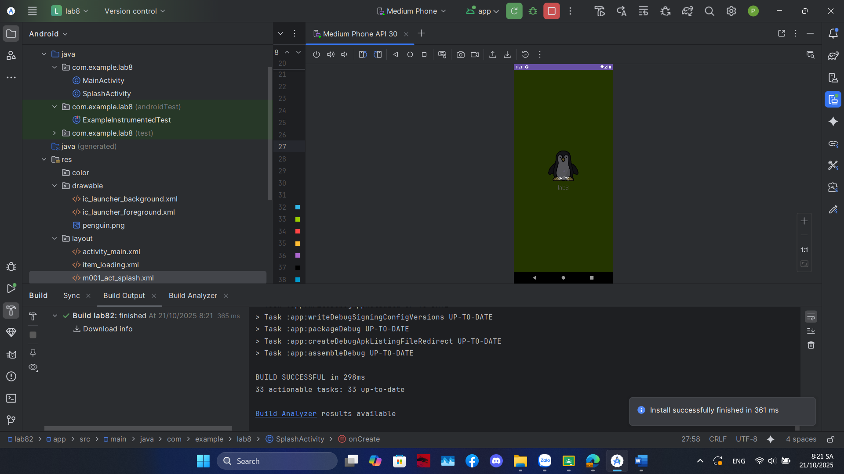

**Item_loading:**

<?xml version="1.0" encoding="utf-8"?>  
<LinearLayout xmlns:android="http://schemas.android.com/apk/res/android"  
 android:layout_width="match_parent"  
 android:layout_height="match_parent"  
 android:background="#A6000000"  
 android:gravity="center"  
 android:orientation="vertical"  
 android:clickable="true"  
 android:focusable="true">  
 <ProgressBar  
 android:layout_width="wrap_content"  
 android:layout_height="wrap_content"  
 android:indeterminate="true" />  
  
 <TextView  
 android:layout_width="wrap_content"  
 android:layout_height="wrap_content"  
 android:layout_marginTop="10dp"  
 android:text="Loading..."  
 android:textColor="@color/white"  
 android:textSize="18sp"  
 android:fontFamily="sans-serif-light" />  
  
</LinearLayout>

### Bài 3: Lập trình để khi bấm vào icon thì chuyển về cuộc gọi, sử dụng Intent.

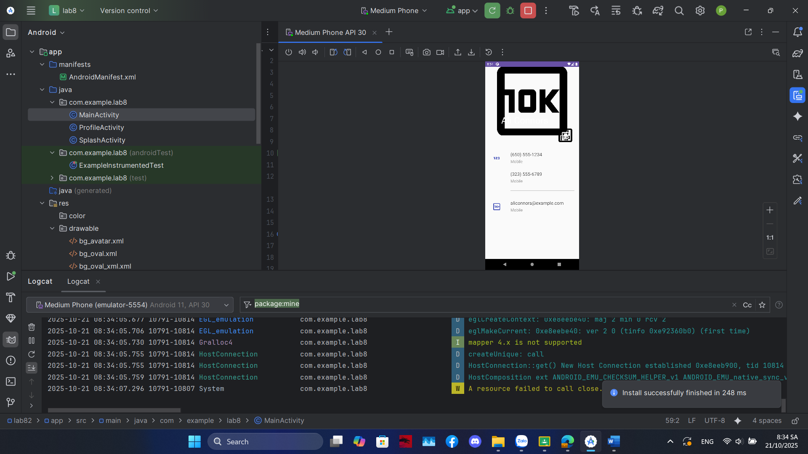

**Tạo file m001_act_profile.xml**

<?xml version="1.0" encoding="utf-8"?>  
<LinearLayout xmlns:android="http://schemas.android.com/apk/res/android"  
 xmlns:app="http://schemas.android.com/apk/res-auto"  
 xmlns:tools="http://schemas.android.com/tools"  
 android:layout_width="match_parent"  
 android:layout_height="match_parent"  
 android:background="@color/gray_light"  
 android:orientation="vertical"  
 tools:context=".ProfileActivity">  
  
 <FrameLayout  
 android:layout_width="match_parent"  
 android:layout_height="350dp">  
 <ImageView  
 android:layout_width="match_parent"  
 android:layout_height="300dp"  
 android:scaleType="centerCrop"  
 android:src="@drawable/dog"  
 tools:ignore="ContentDescription" />  
 <TextView  
 android:layout_width="wrap_content"  
 android:layout_height="wrap_content"  
 android:layout_gravity="bottom"  
 android:layout_marginStart="70dp"  
 android:layout_marginBottom="90dp"  
 android:fontFamily="sans-serif"  
 android:text="@string/txt_name"  
 android:textColor="@color/black"  
 android:textSize="40sp" />  
 <ImageView  
 android:layout_width="80dp"  
 android:layout_height="80dp"  
 android:layout_gravity="end|bottom"  
 android:layout_marginEnd="20dp"  
 android:layout_marginBottom="10dp"  
 android:background="@drawable/bg_oval"  
 android:padding="20dp"  
 android:src="@drawable/ic_star"  
 app:tint="@color/white"  
 tools:ignore="ContentDescription" />  
 </FrameLayout>  
  
 <TableRow  
 android:id="@+id/row_phone_1"  
 android:layout_width="match_parent"  
 android:layout_height="wrap_content"  
 android:background="?attr/selectableItemBackground"  
 android:clickable="true"  
 android:focusable="true"  
 android:padding="20dp">  
 <ImageView  
 android:layout_width="60dp"  
 android:layout_height="60dp"  
 android:padding="10dp"  
 android:src="@drawable/ic_phone"  
 app:tint="@color/indigo"  
 tools:ignore="ContentDescription"/>  
 <LinearLayout  
 android:layout_width="match_parent"  
 android:layout_height="wrap_content"  
 android:layout_marginStart="30dp"  
 android:orientation="vertical">  
 <TextView  
 android:layout_width="match_parent"  
 android:layout_height="wrap_content"  
 android:text="@string/txt_phone1"  
 android:textColor="@color/gray_dark"  
 android:textSize="20sp" />  
 <TextView  
 android:layout_width="match_parent"  
 android:layout_height="wrap_content"  
 android:layout_marginTop="5dp"  
 android:text="@string/txt_title_mobile"  
 android:textColor="@color/gray_mid"  
 android:textSize="18sp" />  
  
 <TextView  
 android:layout_width="match_parent"  
 android:layout_height="wrap_content"  
 android:layout_marginTop="30dp"  
 android:text="@string/txt_phone2"  
 android:textColor="@color/gray_dark"  
 android:textSize="20sp" />  
 <TextView  
 android:layout_width="match_parent"  
 android:layout_height="wrap_content"  
 android:layout_marginTop="5dp"  
 android:text="@string/txt_title_mobile"  
 android:textColor="@color/gray_mid"  
 android:textSize="18sp" />  
 <View  
 android:layout_width="match_parent"  
 android:layout_height="0.5dp"  
 android:layout_marginTop="30dp"  
 android:background="@color/gray_mid"/>  
 </LinearLayout>  
 </TableRow>  
  
 <TableRow  
 android:id="@+id/row_email"  
 android:layout_width="match_parent"  
 android:layout_height="wrap_content"  
 android:background="?attr/selectableItemBackground"  
 android:clickable="true"  
 android:focusable="true"  
 android:padding="20dp">  
 <ImageView  
 android:layout_width="60dp"  
 android:layout_height="60dp"  
 android:padding="10dp"  
 android:src="@drawable/ic_email"  
 app:tint="@color/indigo"  
 tools:ignore="ContentDescription"/>  
 <LinearLayout  
 android:layout_width="match_parent"  
 android:layout_height="match_parent"  
 android:layout_marginStart="30dp"  
 android:orientation="vertical">  
 <TextView  
 android:layout_width="match_parent"  
 android:layout_height="wrap_content"  
 android:text="@string/txt_email"  
 android:textColor="@color/gray_dark"  
 android:textSize="20sp" />  
 <TextView  
 android:layout_width="match_parent"  
 android:layout_height="wrap_content"  
 android:layout_marginTop="5dp"  
 android:text="@string/txt_title_mobile"  
 android:textColor="@color/gray_mid"  
 android:textSize="18sp" />  
 </LinearLayout>  
 </TableRow>  
 <TableRow  
 android:id="@+id/row_sms"  
 android:layout_width="match_parent"  
 android:layout_height="wrap_content"  
 android:background="?attr/selectableItemBackground"  
 android:clickable="true"  
 android:focusable="true"  
 android:padding="20dp">  
  
 <ImageView  
 android:layout_width="60dp"  
 android:layout_height="60dp"  
 android:padding="10dp"  
 android:src="@drawable/ic_sms"  
 app:tint="@color/indigo"  
 tools:ignore="ContentDescription" />  
   
  
 <LinearLayout  
 android:layout_width="match_parent"  
 android:layout_height="match_parent"  
 android:layout_marginStart="30dp"  
 android:orientation="vertical">  
  
 <TextView  
 android:layout_width="match_parent"  
 android:layout_height="wrap_content"  
 android:text="@string/txt_phone1"  
 android:textColor="@color/gray_dark"  
 android:textSize="20sp" />  
  
 <TextView  
 android:layout_width="match_parent"  
 android:layout_height="wrap_content"  
 android:layout_marginTop="5dp"  
 android:text="Send Message"  
 android:textColor="@color/gray_mid"  
 android:textSize="18sp" />  
 </LinearLayout>  
 </TableRow>  
  
</LinearLayout>

**Kế tiếp tạo file ProfileActivity.java**

package com.example.lab2th;   
  
import androidx.annotation.NonNull;  
import androidx.appcompat.app.AppCompatActivity;  
import androidx.core.app.ActivityCompat;  
import androidx.core.content.ContextCompat;  
  
import android.content.Intent;  
import android.content.pm.PackageManager;  
import android.net.Uri;  
import android.os.Bundle;  
import android.telephony.SmsManager;   
import android.view.View;  
import android.widget.TableRow;  
import android.widget.Toast;  
  
public class ProfileActivity extends AppCompatActivity {  
 private static final int *REQUEST_CALL_PHONE* = 1;  
 private static final int *REQUEST_SEND_SMS* = 2;   
  
 TableRow rowPhone1;  
 TableRow rowEmail;  
 TableRow rowSms;  
  
 private String phoneNumber1;  
  
 @Override  
 protected void onCreate(Bundle savedInstanceState) {  
 super.onCreate(savedInstanceState);  
 setContentView(R.layout.*m001_act_profile*);  
  
  
 rowPhone1 = findViewById(R.id.*row_phone_1*);  
 rowEmail = findViewById(R.id.*row_email*);  
 rowSms = findViewById(R.id.*row_sms*);   
 phoneNumber1 = getString(R.string.*txt_phone1*);  
 final String emailAddress = getString(R.string.*txt_email*);  
 rowPhone1.setOnClickListener(new View.OnClickListener() {  
 @Override  
 public void onClick(View v) {  
 makePhoneCall();  
 }  
 });  
  
  
 rowEmail.setOnClickListener(new View.OnClickListener() {  
 @Override  
 public void onClick(View v) {  
 composeEmail(emailAddress);  
 }  
 });  
  
  
 if (rowSms != null) {  
 rowSms.setOnClickListener(new View.OnClickListener() {  
 @Override  
 public void onClick(View v) {  
 sendSms();  
 }  
 });  
 }  
 }  
  
private void makePhoneCall() {  
 if (ContextCompat.*checkSelfPermission*(this, android.Manifest.permission.*CALL_PHONE*)  
 != PackageManager.*PERMISSION_GRANTED*) {  
 ActivityCompat.*requestPermissions*(this,  
 new String[]{android.Manifest.permission.*CALL_PHONE*},  
 *REQUEST_CALL_PHONE*);  
 } else {  
 Intent intent = new Intent(Intent.*ACTION_CALL*);  
 intent.setData(Uri.*parse*("tel:" + phoneNumber1));  
 startActivity(intent);  
 }  
 }  
  
private void composeEmail(String emailAddress) {  
 Intent intent = new Intent(Intent.*ACTION_SENDTO*);  
 intent.setData(Uri.*parse*("mailto:" + emailAddress));  
 if (intent.resolveActivity(getPackageManager()) != null) {  
 startActivity(intent);  
 }  
 }private void sendSms() {  
   
 if (ContextCompat.*checkSelfPermission*(this, android.Manifest.permission.*SEND_SMS*)  
 != PackageManager.*PERMISSION_GRANTED*) {  
  
 ActivityCompat.*requestPermissions*(this,  
 new String[]{android.Manifest.permission.*SEND_SMS*},  
 *REQUEST_SEND_SMS*);  
 } else {  
   
 try {  
 SmsManager smsManager = SmsManager.*getDefault*();  
  
 smsManager.sendTextMessage(phoneNumber1, null, "Hello from ProfileActivity!", null, null);  
 Toast.*makeText*(this, "SMS sent", Toast.*LENGTH_SHORT*).show();  
 } catch (Exception e) {  
  
 Toast.*makeText*(this, "Failed to send SMS", Toast.*LENGTH_SHORT*).show();  
 e.printStackTrace();  
 }  
 }  
 }  
  
  
@Override  
 public void onRequestPermissionsResult(int requestCode, @NonNull String[] permissions, @NonNull int[] grantResults) {  
 super.onRequestPermissionsResult(requestCode, permissions, grantResults);  
  
 if (requestCode == *REQUEST_CALL_PHONE*) {  
 if (grantResults.length > 0 && grantResults[0] == PackageManager.*PERMISSION_GRANTED*) {  
 makePhoneCall();  
 } else {  
 Toast.*makeText*(this, "Call permission denied", Toast.*LENGTH_SHORT*).show();  
 }  
 }  
 else if (requestCode == *REQUEST_SEND_SMS*) {  
 if (grantResults.length > 0 && grantResults[0] == PackageManager.*PERMISSION_GRANTED*) {  
   
 sendSms();  
 } else {  
 Toast.*makeText*(this, "Send SMS permission denied", Toast.*LENGTH_SHORT*).show();  
 }  
 }  
 }  
}

**Sau đó vào androidMainFest.xml để thêm activity của ProfileActivity vào, và thêm các dòng để gọi thành công**

<uses-permission android:name="android.permission.CALL_PHONE" />  
<uses-permission android:name="android.permission.SEND_SMS" />  
<uses-feature android:name="android.hardware.telephony" android:required="false" />

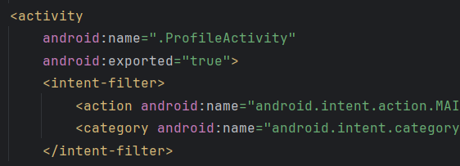

**đã có thể gọi được khi click vào phone**

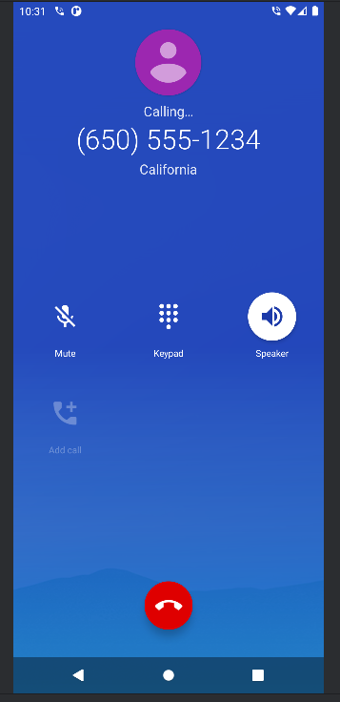

**Gửi sms thành công**

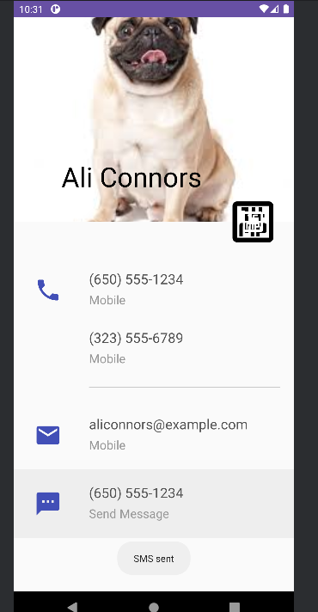

### Bài 4: Tạo màn hình chính MainActivity để chuyển qua và chuyển về giữa các màn hình

ở các phần luyện tập.

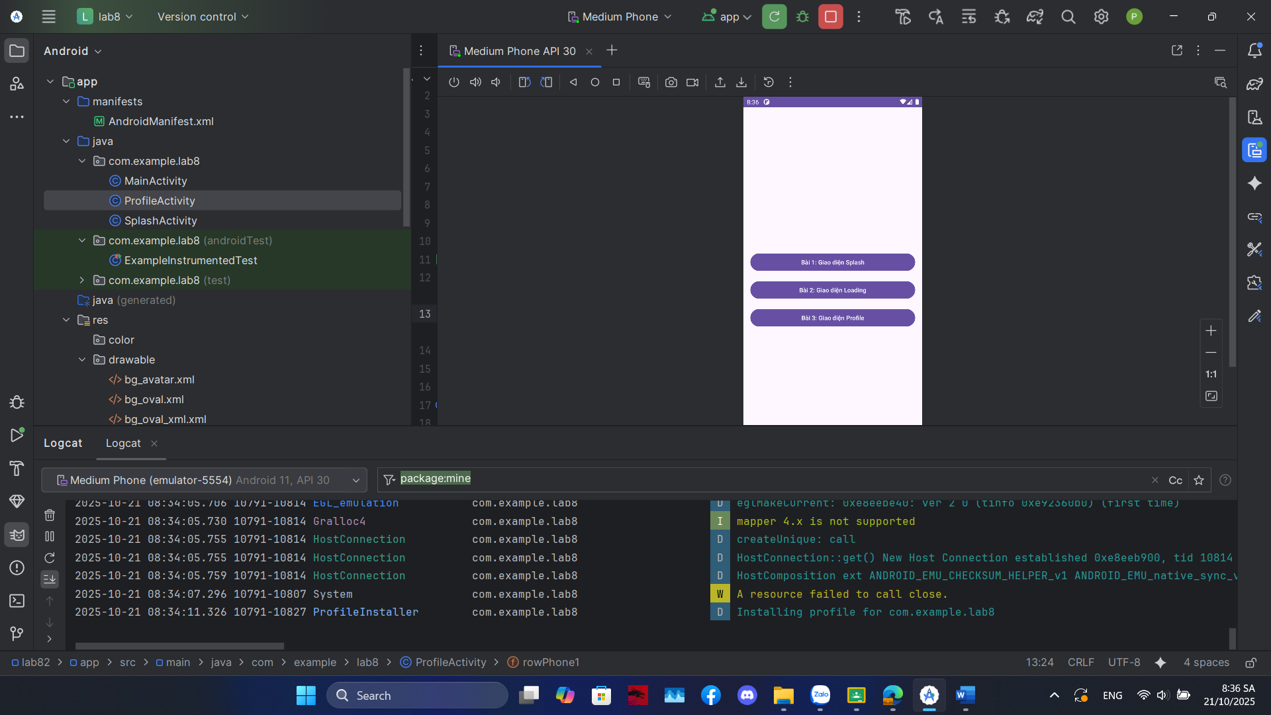

**Activity_main.xml**

<?xml version="1.0" encoding="utf-8"?>  
<LinearLayout xmlns:android="http://schemas.android.com/apk/res/android"  
 xmlns:tools="http://schemas.android.com/tools"  
 android:layout_width="match_parent"  
 android:layout_height="match_parent"  
 android:orientation="vertical"  
 android:gravity="center"  
 android:padding="16dp"  
 tools:context=".MainActivity">  
  
 <Button  
 android:id="@+id/btnBai1"  
 android:layout_width="match_parent"  
 android:layout_height="wrap_content"  
 android:text="Bài 1: Giao diện Splash" />  
  
 <Button  
 android:id="@+id/btnBai2"  
 android:layout_width="match_parent"  
 android:layout_height="wrap_content"  
 android:layout_marginTop="16dp"  
 android:text="Bài 2: Giao diện Loading" />  
  
 <Button  
 android:id="@+id/btnBai3"  
 android:layout_width="match_parent"  
 android:layout_height="wrap_content"  
 android:layout_marginTop="16dp"  
 android:text="Bài 3: Giao diện Profile" />  
  
</LinearLayout>

**Mainactivity.java**

package com.example.lab8;

import androidx.appcompat.app.AppCompatActivity;

import android.content.Intent;

import android.os.Bundle;

import android.view.View;

import android.widget.Button;

public class MainActivity extends AppCompatActivity {

Button btnBai1, btnBai2, btnBai3;

@Override

protected void onCreate(Bundle savedInstanceState) {

super.onCreate(savedInstanceState);

setContentView(R.layout.activity_main);

btnBai1 = findViewById(R.id.btnBai1);

btnBai2 = findViewById(R.id.btnBai2);

btnBai3 = findViewById(R.id.btnBai3);

btnBai1.setOnClickListener(new View.OnClickListener() {

@Override

public void onClick(View v) {

openDisplay(false);

}

});

btnBai2.setOnClickListener(new View.OnClickListener() {

@Override

public void onClick(View v) {

openDisplay(true);

}

});

btnBai3.setOnClickListener(new View.OnClickListener() {

@Override

public void onClick(View v) {

Intent intent = new Intent(MainActivity.this, ProfileActivity.class);

startActivity(intent);

}

});

}

private void openDisplay(boolean showLoading) {

Intent intent = new Intent(MainActivity.this, SplashActivity.class);

intent.putExtra("SHOW_LOADING", showLoading);

startActivity(intent);

}

}

# Lab2

## **Lab3**

### Bài 1: Xây dựng ứng dụng Truyện Cười (P1)

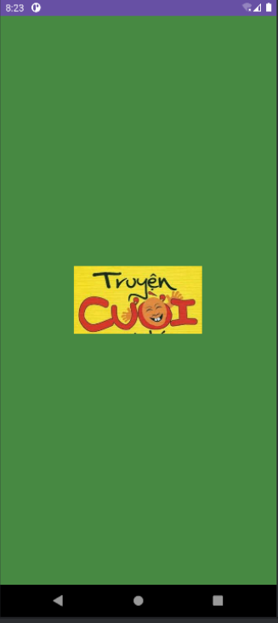

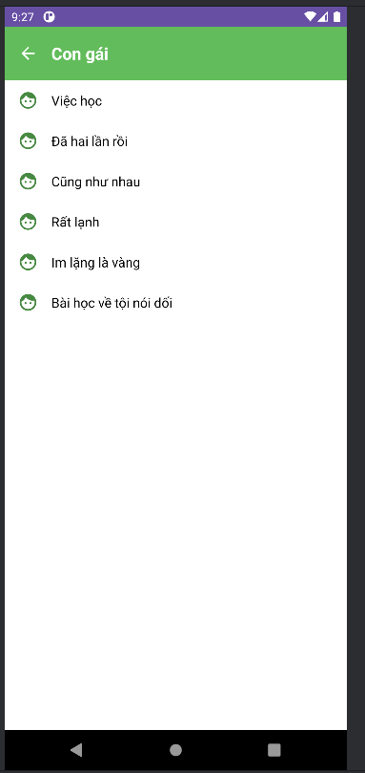

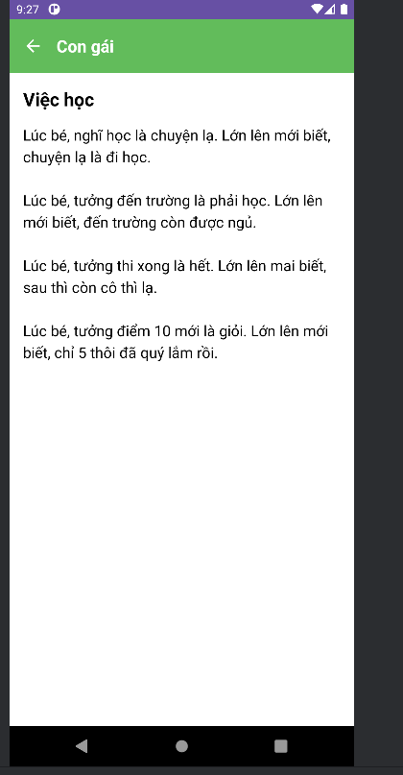

SwitchCompat swRotate = view.findViewById(R.id.sw_rotate);

if (getActivity() != null) {

if (swRotate.isChecked()) {

getActivity().setRequestedOrientation(ActivityInfo.SCREEN_ORIENTATION_SENSOR);

} else {

getActivity().setRequestedOrientation(ActivityInfo.SCREEN_ORIENTATION_PORTRAIT);

}

}

swRotate.setOnCheckedChangeListener((buttonView, isChecked) -> {

if (getActivity() == null) return;

if (isChecked) getActivity().setRequestedOrientation(ActivityInfo.SCREEN_ORIENTATION_SENSOR);

} else { getActivity().setRequestedOrientation(ActivityInfo.SCREEN_ORIENTATION_PORTRAIT);

}

});

**Giai đoạn 1: Khởi tạo (Khi Fragment được tải)**

* Tìm Switch (nút gạt) trong layout bằng findViewById.
* Kiểm tra trạng thái *hiện tại* của Switch:
  + Nếu Switch đang "On" (isChecked() là true), nó gọi setRequestedOrientation(ActivityInfo.SCREEN_ORIENTATION_SENSOR) để **cho phép** ứng dụng xoay theo cảm biến.
  + Nếu Switch đang "Off" (isChecked() là false), nó gọi setRequestedOrientation(ActivityInfo.SCREEN_ORIENTATION_PORTRAIT) để **khóa** ứng dụng ở chế độ màn hình dọc.
* *Đây là bước quan trọng để duy trì trạng thái "Off" ngay cả khi màn hình bị xoay và tạo lại.*

**Giai đoạn 2: Lắng nghe sự kiện (Khi người dùng bấm vào Switch)**

* Gắn một setOnCheckedChangeListener vào Switch. Đoạn code bên trong này chỉ chạy *khi người dùng tương tác* gạt nút.
* Khi sự kiện xảy ra, nó kiểm tra trạng thái *mới* (isChecked):
  + Nếu người dùng gạt "On" (isChecked là true), nó **cho phép** xoay (SENSOR).
  + Nếu người dùng gạt "Off" (isChecked là false), nó **khóa dọc** (PORTRAIT).

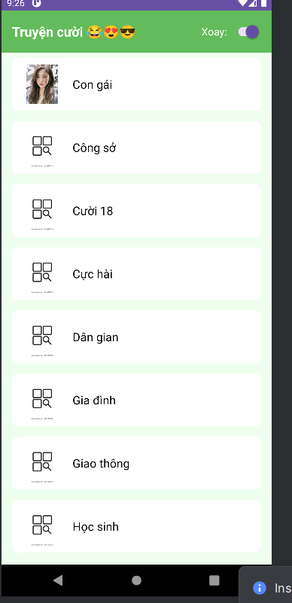

### Bài 2: Sử dụng các kiến thức đã giới thiệu ở phần đa ngữ ở trên, thiết kế chương trình

cho phép chọn các ngôn ngữ như sau:

**Tạo file bài**

Ta thêm các file ngôn ngữ theo cách:

**Tạo res/values-vi/strings.xml (Tiếng Việt):**

* Nhấp chuột phải vào res -> **New** -> **Android Resource File**.
* Tên file: strings.xml.
* Qualifier: Chọn **Locale** -> >> -> **Language: vi (Vietnamese)**.
* Nhấn **OK**.
* Chép code sau vào file res/values-vi/strings.xml vừa tạo:
* <?xml version="1.0" encoding="utf-8"?>  
  <resources>  
   <string name="app_name">Truyện Cười</string>  
    
   <string name="welcome_message">Xin chào</string>  
   <string name="email_hint">Email</string>  
   <string name="password_hint">Mật khẩu</string>  
   <string name="no_account">Không có tài khoản. Vui lòng đăng ký</string>
* </resources>

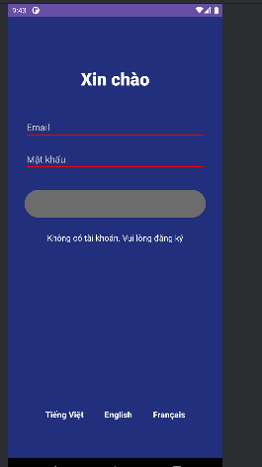

Hàm giúp chuyển đổi ngôn ngữ  
private void setLocale(String langCode) {  
   
 Locale locale = new Locale(langCode);  
 Locale.*setDefault*(locale);  
 Resources res = getResources();  
 Configuration config = res.getConfiguration();  
 config.setLocale(locale);  
 res.updateConfiguration(config, res.getDisplayMetrics());  
 Intent intent = new Intent(this, LoginBai2Activity.class);  
 startActivity(intent);  
 finish();  
}

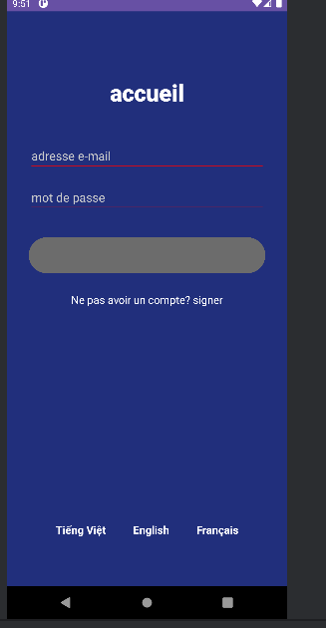

File activity_login_bai2:

<?xml version="1.0" encoding="utf-8"?>  
<androidx.constraintlayout.widget.ConstraintLayout xmlns:android="http://schemas.android.com/apk/res/android"  
 xmlns:app="http://schemas.android.com/apk/res-auto"  
 xmlns:tools="http://schemas.android.com/tools"  
 android:layout_width="match_parent"  
 android:layout_height="match_parent"  
 android:background="#212F7C"  
 android:padding="32dp"  
 tools:context=".LoginBai2Activity">  
  
 <TextView  
 android:id="@+id/tv_welcome"  
 android:layout_width="wrap_content"  
 android:layout_height="wrap_content"  
 android:layout_marginTop="64dp"  
 android:fontFamily="sans-serif-medium"  
 android:text="@string/welcome_message"  
 android:textColor="@color/white"  
 android:textSize="34sp"  
 android:textStyle="bold"  
 app:layout_constraintEnd_toEndOf="parent"  
 app:layout_constraintStart_toStartOf="parent"  
 app:layout_constraintTop_toTopOf="parent" />  
  
 <EditText  
 android:id="@+id/et_email"  
 android:layout_width="0dp"  
 android:layout_height="wrap_content"  
 android:layout_marginTop="48dp"  
 android:hint="@string/email_hint"  
 android:inputType="textEmailAddress"  
 android:textColor="@color/white"  
 android:textColorHint="#CCCCCC"  
 android:backgroundTint="#FF0000"  
 app:layout_constraintEnd_toEndOf="parent"  
 app:layout_constraintStart_toStartOf="parent"  
 app:layout_constraintTop_toBottomOf="@id/tv_welcome" />  
  
 <EditText  
 android:id="@+id/et_password"  
 android:layout_width="0dp"  
 android:layout_height="wrap_content"  
 android:layout_marginTop="16dp"  
 android:hint="@string/password_hint"  
 android:inputType="textPassword"  
 android:textColor="@color/white"  
 android:textColorHint="#CCCCCC"  
 android:backgroundTint="#FF0000"  
 app:layout_constraintEnd_toEndOf="parent"  
 app:layout_constraintStart_toStartOf="parent"  
 app:layout_constraintTop_toBottomOf="@id/et_email" />  
  
 <Button  
 android:id="@+id/btn_login"  
 android:layout_width="0dp"  
 android:layout_height="60dp"  
 android:layout_marginTop="32dp"  
 android:backgroundTint="#6C6C6C"  
 android:text=""  
 app:layout_constraintEnd_toEndOf="parent"  
 app:layout_constraintStart_toStartOf="parent"  
 app:layout_constraintTop_toBottomOf="@id/et_password" />  
  
 <TextView  
 android:id="@+id/tv_signup"  
 android:layout_width="wrap_content"  
 android:layout_height="wrap_content"  
 android:layout_marginTop="24dp"  
 android:text="@string/no_account"  
 android:textColor="@color/white"  
 android:textSize="16sp"  
 app:layout_constraintEnd_toEndOf="parent"  
 app:layout_constraintStart_toStartOf="parent"  
 app:layout_constraintTop_toBottomOf="@id/btn_login" />  
  
 <LinearLayout  
 android:layout_width="wrap_content"  
 android:layout_height="wrap_content"  
 android:orientation="horizontal"  
 app:layout_constraintBottom_toBottomOf="parent"  
 app:layout_constraintEnd_toEndOf="parent"  
 app:layout_constraintStart_toStartOf="parent"  
 android:layout_marginBottom="32dp">  
  
 <TextView  
 android:id="@+id/tv_lang_vi"  
 android:layout_width="wrap_content"  
 android:layout_height="wrap_content"  
 android:text="@string/lang_vi"  
 android:textColor="@color/white"  
 android:textSize="16sp"  
 android:textStyle="bold"  
 android:padding="8dp"/>  
  
 <TextView  
 android:id="@+id/tv_lang_en"  
 android:layout_width="wrap_content"  
 android:layout_height="wrap_content"  
 android:layout_marginHorizontal="24dp"  
 android:text="@string/lang_en"  
 android:textColor="@color/white"  
 android:textSize="16sp"  
 android:textStyle="bold"  
 android:padding="8dp"/>  
  
 <TextView  
 android:id="@+id/tv_lang_fr"  
 android:layout_width="wrap_content"  
 android:layout_height="wrap_content"  
 android:text="@string/lang_fr"  
 android:textColor="@color/white"  
 android:textSize="16sp"  
 android:textStyle="bold"  
 android:padding="8dp"/>  
 </LinearLayout>  
  
</androidx.constraintlayout.widget.ConstraintLayout>

## Lab4

Tạo các file activity

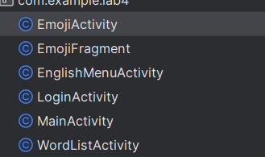

Nhớ khai báo trong mainfest

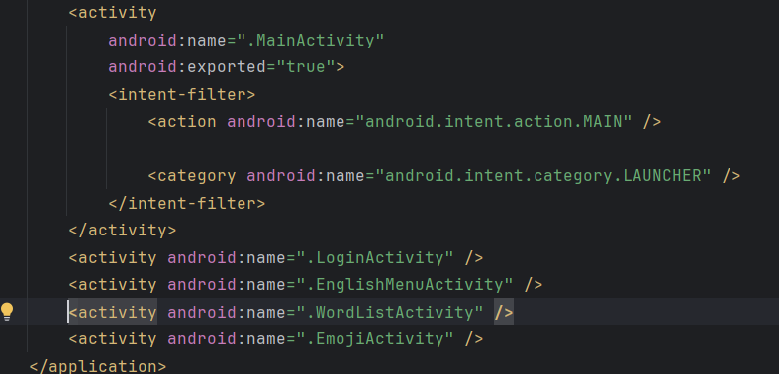

File color.xml

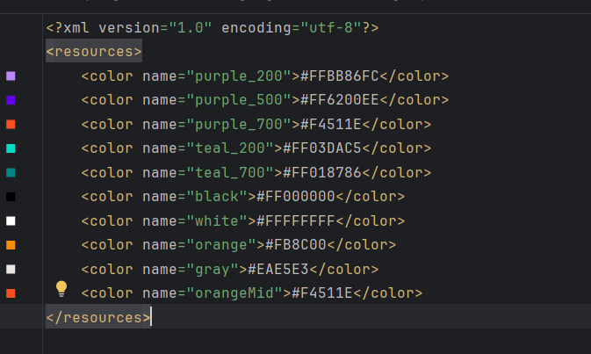

File String.xml

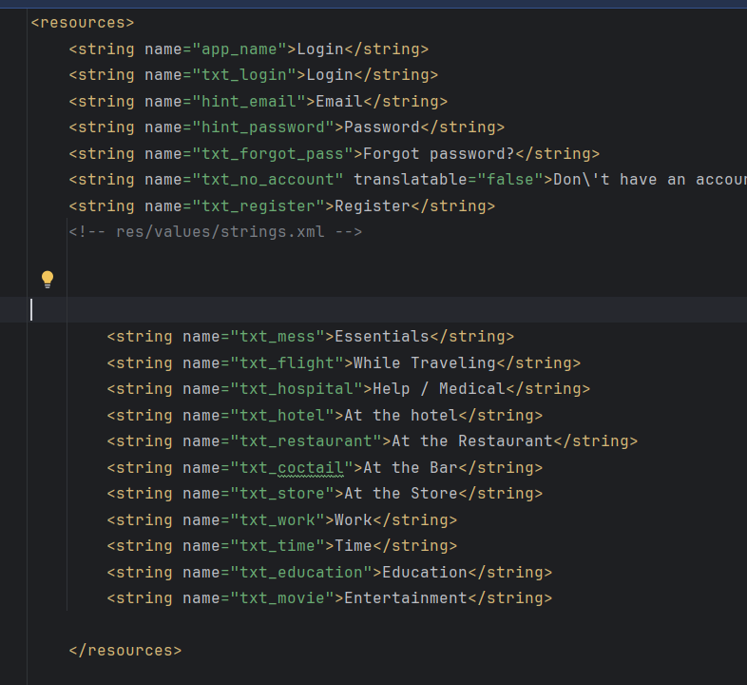

### Bài 1 tạo login

**File xml**

<?xml version="1.0" encoding="utf-8"?>  
<LinearLayout xmlns:android="http://schemas.android.com/apk/res/android"  
 android:layout_width="match_parent"  
 android:layout_height="match_parent"  
 android:background="@color/gray"  
 android:orientation="vertical">  
  
  
 <FrameLayout  
 android:layout_width="match_parent"  
 android:layout_height="wrap_content">  
 <View  
 android:layout_width="match_parent"  
 android:layout_height="300dp"  
 android:background="@drawable/bg_top" />  
 <TextView  
 android:layout_width="wrap_content"  
 android:layout_height="wrap_content"  
 android:layout_gravity="end"  
 android:layout_marginTop="220dp"  
 android:layout_marginEnd="30dp"  
 android:text="@string/txt_login"  
 android:textColor="@color/white"  
 android:textSize="20sp" />  
 </FrameLayout>  
  
  
 <EditText  
 android:id="@+id/edt_email"  
 android:layout_width="match_parent"  
 android:layout_height="50dp"  
 android:layout_marginHorizontal="30dp"  
 android:layout_marginTop="50dp"  
 android:layout_marginBottom="3dp"  
 android:background="@drawable/bg_radius"  
 android:drawableStart="@drawable/ic_mail"  
 android:drawablePadding="10dp"  
 android:hint="@string/hint_email"  
 android:padding="10dp"  
 android:textSize="18sp" />  
  
   
 <EditText  
 android:id="@+id/edt_password"  
 android:layout_width="match_parent"  
 android:layout_height="50dp"  
 android:layout_marginHorizontal="30dp"  
 android:layout_marginTop="20dp"  
 android:layout_marginBottom="3dp"  
 android:background="@drawable/bg_radius"  
 android:drawableStart="@drawable/ic_key"  
 android:drawablePadding="10dp"  
 android:hint="@string/hint_password"  
 android:inputType="textPassword"  
 android:padding="10dp"  
 android:textSize="18sp" />  
  
  
 <TextView  
 android:layout_width="wrap_content"  
 android:layout_height="wrap_content"  
 android:layout_gravity="end"  
 android:layout_marginTop="10dp"  
 android:layout_marginEnd="30dp"  
 android:text="@string/txt_forgot_pass"  
 android:textColor="@color/black"  
 android:textSize="18sp" />  
  
  
 <Button  
 android:id="@+id/btn_login"  
 android:layout_width="match_parent"  
 android:layout_height="50dp"  
 android:layout_marginHorizontal="30dp"  
 android:layout_marginTop="50dp"  
 android:background="@drawable/bg_login"  
 android:text="@string/txt_login"  
 android:textColor="@color/white"  
 android:textSize="18sp" />  
  
 <TableRow  
 android:layout_width="match_parent"  
 android:layout_height="wrap_content"  
 android:layout_marginTop="50dp"  
 android:gravity="center">  
 <TextView  
 android:layout_width="wrap_content"  
 android:layout_height="wrap_content"  
 android:text="@string/txt_no_account"  
 android:textColor="@color/black"  
 android:textSize="14sp" />  
 <TextView  
 android:layout_width="wrap_content"  
 android:layout_height="wrap_content"  
 android:text="@string/txt_register"  
 android:textColor="@color/orange"  
 android:textSize="14sp"  
 android:textStyle="bold" />  
 </TableRow>  
</LinearLayout>

Tạo các nút và nền bg_rect.xml, bg_login.xml, bg_top.xml

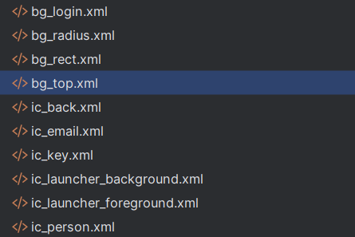

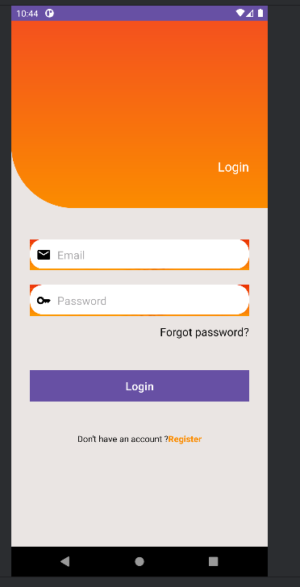

### Bài 2: Tạo giao diện menu

Tạo file xml

<LinearLayout xmlns:android="http://schemas.android.com/apk/res/android"  
 xmlns:tools="http://schemas.android.com/tools"  
 android:layout_width="match_parent"  
 android:layout_height="match_parent"  
 android:orientation="vertical"  
 tools:context=".EnglishMenuActivity">  
  
   
 <include layout="@layout/actionbar_home" />  
  
  
 <LinearLayout  
 android:id="@+id/ln_topics"  
 android:layout_width="match_parent"  
 android:layout_height="match_parent"  
 android:orientation="vertical"  
 android:padding="10dp" />  
  
</LinearLayout>

**Tạo file item_topic**

<?xml version="1.0" encoding="utf-8"?>  
<LinearLayout xmlns:android="http://schemas.android.com/apk/res/android"  
 android:layout_width="match_parent"  
 android:layout_height="match_parent"  
 android:orientation="horizontal"  
 android:background="?android:attr/selectableItemBackground">  
  
 <ImageView  
 android:id="@+id/iv_icon"  
 android:layout_width="64dp"  
 android:layout_height="match_parent"  
 android:src="@drawable/ic_mess" />  
  
 <TextView  
 android:id="@+id/tv_title"  
 android:layout_width="match_parent"  
 android:layout_height="match_parent"  
 android:gravity="center_vertical"  
 android:paddingStart="16dp"  
 android:textSize="18sp"  
 android:textColor="@android:color/black" />  
</LinearLayout>

Hàm xử lý  
private void initTopics() { LinearLayout container = findViewById(R.id.ln_topics); for (int i = 0; i < DRAWABLES.length; i++) { View item = LayoutInflater.from(this).inflate(R.layout.item_topic, null); ImageView iv = item.findViewById(R.id.iv_icon); TextView tv = item.findViewById(R.id.tv_title); iv.setImageResource(DRAWABLES[i]); tv.setText(TEXTS[i]);

String topic = getString(TEXTS[i]); item.setOnClickListener(v -> { Intent intent = new Intent(this, WordListActivity.class); intent.putExtra("TOPIC", topic); startActivity(intent); });

container.addView(item); } }

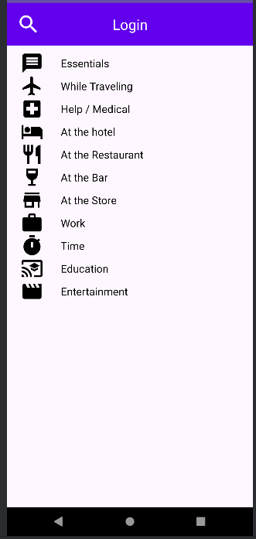

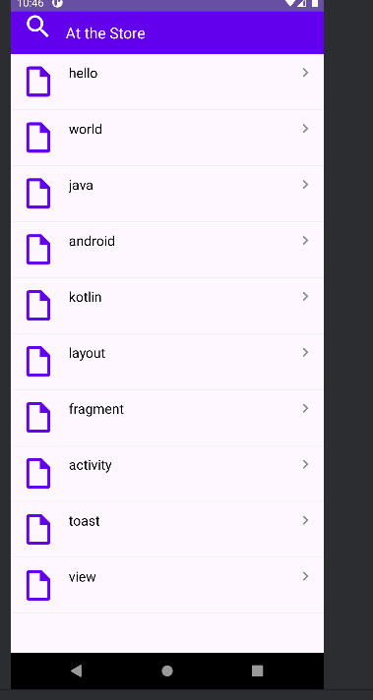

### Bài 3: Tạo giao diện Toast Emoij

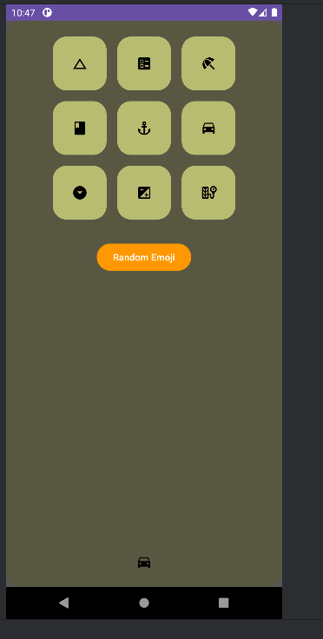

Tạo file fragment_emoji.xml

<?xml version="1.0" encoding="utf-8"?>  
<FrameLayout xmlns:android="http://schemas.android.com/apk/res/android"  
 android:layout_width="match_parent"  
 android:layout_height="match_parent">  
  
  
 <ImageView  
 android:layout_width="match_parent"  
 android:layout_height="match_parent"  
 android:src="@drawable/bg_emoij"  
 android:scaleType="centerCrop" />  
  
  
 <LinearLayout  
 android:layout_width="match_parent"  
 android:layout_height="match_parent"  
 android:background="#A6000000"  
 android:orientation="vertical"  
 android:padding="24dp">  
  
 <TableRow  
 android:layout_width="match_parent"  
 android:layout_height="wrap_content"  
 android:gravity="center"  
 android:layout_marginBottom="16dp">  
  
 <ImageView  
 android:id="@+id/iv1"  
 android:layout_width="80dp"  
 android:layout_height="80dp"  
 android:src="@drawable/ic_angry"  
 android:background="@drawable/bg_emoij"  
 android:padding="16dp"  
 android:scaleType="centerInside" />  
  
 <ImageView  
 android:id="@+id/iv2"  
 android:layout_width="80dp"  
 android:layout_height="80dp"  
 android:src="@drawable/ic_baffle"  
 android:background="@drawable/bg_emoij"  
 android:padding="16dp"  
 android:scaleType="centerInside"  
 android:layout_marginStart="16dp" />  
  
 <ImageView  
 android:id="@+id/iv3"  
 android:layout_width="80dp"  
 android:layout_height="80dp"  
 android:src="@drawable/ic_beauty"  
 android:background="@drawable/bg_emoij"  
 android:padding="16dp"  
 android:scaleType="centerInside"  
 android:layout_marginStart="16dp" />  
 </TableRow>  
  
  
 <TableRow  
 android:layout_width="match_parent"  
 android:layout_height="wrap_content"  
 android:gravity="center"  
 android:layout_marginBottom="16dp">  
  
 <ImageView  
 android:id="@+id/iv4"  
 android:layout_width="80dp"  
 android:layout_height="80dp"  
 android:src="@drawable/ic_boss"  
 android:background="@drawable/bg_emoij"  
 android:padding="16dp"  
 android:scaleType="centerInside" />  
  
 <ImageView  
 android:id="@+id/iv5"  
 android:layout_width="80dp"  
 android:layout_height="80dp"  
 android:src="@drawable/ic_choler"  
 android:background="@drawable/bg_emoij"  
 android:padding="16dp"  
 android:scaleType="centerInside"  
 android:layout_marginStart="16dp" />  
  
 <ImageView  
 android:id="@+id/iv6"  
 android:layout_width="80dp"  
 android:layout_height="80dp"  
 android:src="@drawable/ic_dribble"  
 android:background="@drawable/bg_emoij"  
 android:padding="16dp"  
 android:scaleType="centerInside"  
 android:layout_marginStart="16dp" />  
 </TableRow>  
  
   
 <TableRow  
 android:layout_width="match_parent"  
 android:layout_height="wrap_content"  
 android:gravity="center"  
 android:layout_marginBottom="32dp">  
  
 <ImageView  
 android:id="@+id/iv7"  
 android:layout_width="80dp"  
 android:layout_height="80dp"  
 android:src="@drawable/ic_look_down"  
 android:background="@drawable/bg_emoij"  
 android:padding="16dp"  
 android:scaleType="centerInside" />  
  
 <ImageView  
 android:id="@+id/iv8"  
 android:layout_width="80dp"  
 android:layout_height="80dp"  
 android:src="@drawable/ic_sure"  
 android:background="@drawable/bg_emoij"  
 android:padding="16dp"  
 android:scaleType="centerInside"  
 android:layout_marginStart="16dp" />  
  
 <ImageView  
 android:id="@+id/iv9"  
 android:layout_width="80dp"  
 android:layout_height="80dp"  
 android:src="@drawable/ic_tire"  
 android:background="@drawable/bg_emoij"  
 android:padding="16dp"  
 android:scaleType="centerInside"  
 android:layout_marginStart="16dp" />  
 </TableRow>  
  
  
 <Button  
 android:id="@+id/btn_random"  
 android:layout_width="wrap_content"  
 android:layout_height="wrap_content"  
 android:text="Random Emoji"  
 android:layout_gravity="center"  
 android:backgroundTint="#FF9800"  
 android:textColor="@android:color/white" />  
  
 </LinearLayout>  
</FrameLayout>

**Hàm xử lý ở trong file EmojiFragment.java**

private final int[] emojiIds = {  
 R.id.*iv1*, R.id.*iv2*, R.id.*iv3*,  
 R.id.*iv4*, R.id.*iv5*, R.id.*iv6*,  
 R.id.*iv7*, R.id.*iv8*, R.id.*iv9*};  
  
@Override  
public View onCreateView(LayoutInflater inflater, ViewGroup container, Bundle savedInstanceState) {  
 View v = inflater.inflate(R.layout.*fragment_emoji*, container, false);  
 initViews(v);  
 return v;  
}  
  
private void initViews(View v) {  
 for (int id : emojiIds) {  
 v.findViewById(id).setOnClickListener(this);  
 }  
 v.findViewById(R.id.*btn_random*).setOnClickListener(this);  
}  
  
@Override  
public void onClick(View v) {  
 ImageView iv;  
 if (v.getId() == R.id.*btn_random*) {  
 Random r = new Random();  
 int idx = r.nextInt(emojiIds.length);  
 iv = getView().findViewById(emojiIds[idx]);  
 } else {  
 iv = (ImageView) v;  
 }  
 showToast(iv.getDrawable());  
}

Tổng các file drawtable cần tạo để làm bài lab4

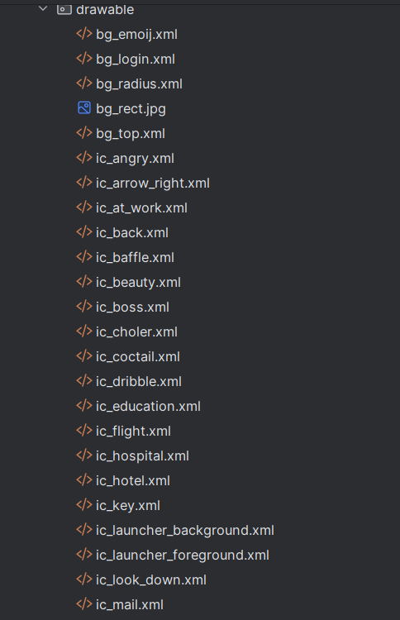

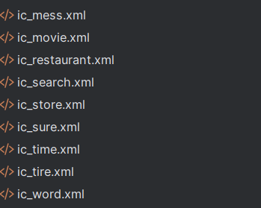

## Lab5

### Bài 1: Xử lý animation trong layout

Tạo file anim trong res

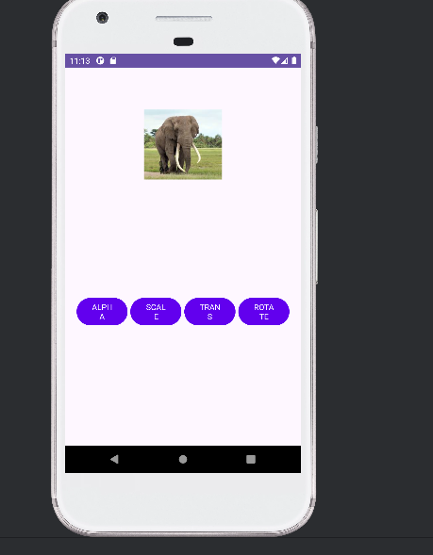

Với 4 file

Alpha.xml  
<?xml version="1.0" encoding="utf-8"?>  
<alpha xmlns:android="http://schemas.android.com/apk/res/android"  
 android:duration="1000"  
 android:fromAlpha="1.0"  
 android:toAlpha="0.0"  
 android:repeatCount="infinite"  
 android:repeatMode="reverse" />

Rotate.xml

<?xml version="1.0" encoding="utf-8"?>  
<rotate xmlns:android="http://schemas.android.com/apk/res/android"  
 android:duration="1000"  
 android:fromDegrees="0"  
 android:toDegrees="360"  
 android:pivotX="50%" android:pivotY="50%"  
 android:repeatCount="infinite"  
 android:repeatMode="reverse" />

Scale.xml

<?xml version="1.0" encoding="utf-8"?>  
<scale xmlns:android="http://schemas.android.com/apk/res/android"  
 android:duration="1000"  
 android:fromXScale="1" android:fromYScale="1"  
 android:toXScale="2" android:toYScale="2"  
 android:pivotX="50%" android:pivotY="50%"  
 android:repeatCount="infinite"  
 android:repeatMode="reverse" />

Trainlaste.xml

<?xml version="1.0" encoding="utf-8"?>  
<translate xmlns:android="http://schemas.android.com/apk/res/android"  
 android:duration="1000"  
 android:fromXDelta="0"  
 android:toXDelta="200"  
 android:repeatCount="infinite"  
 android:repeatMode="reverse" />

File activityanimation.java

<?xml version="1.0" encoding="utf-8"?>  
<LinearLayout xmlns:android="http://schemas.android.com/apk/res/android"  
 xmlns:tools="http://schemas.android.com/tools"  
 android:layout_width="match_parent"  
 android:layout_height="match_parent"  
 android:orientation="vertical"  
 android:gravity="center_horizontal"  
 android:padding="20dp"  
 tools:context=".AnimationActivity">  
  
 <ImageView  
 android:id="@+id/iv_animal"  
 android:layout_width="128dp"  
 android:layout_height="128dp"  
 android:layout_marginTop="50dp"  
 android:src="@drawable/ic_elephant" />  
  
 <TableRow  
 android:layout_width="match_parent"  
 android:layout_height="wrap_content"  
 android:layout_marginTop="200dp">  
  
 <Button android:id="@+id/bt_alpha" style="?android:attr/buttonBarStyle"  
 android:layout_width="0dp" android:layout_height="wrap_content"  
 android:layout_weight="1" android:backgroundTint="@color/design_default_color_primary"  
 android:text="@string/txt_alpha" android:textAllCaps="true" android:textColor="@color/white" />  
  
 <Button android:id="@+id/bt_scale" style="?android:attr/buttonBarStyle"  
 android:layout_width="0dp" android:layout_height="wrap_content"  
 android:layout_weight="1" android:layout_marginStart="5dp"  
 android:backgroundTint="@color/design_default_color_primary"  
 android:text="@string/txt_scale" android:textAllCaps="true" android:textSize="14sp" />  
  
 <Button android:id="@+id/bt_trans" style="?android:attr/buttonBarStyle"  
 android:layout_width="0dp" android:layout_height="wrap_content"  
 android:layout_weight="1" android:layout_marginStart="5dp"  
 android:backgroundTint="@color/design_default_color_primary"  
 android:text="@string/txt_trans" android:textAllCaps="true" android:textSize="14sp" />  
  
 <Button android:id="@+id/bt_rotate" style="?android:attr/buttonBarStyle"  
 android:layout_width="0dp" android:layout_height="wrap_content"  
 android:layout_weight="1" android:layout_marginStart="5dp"  
 android:backgroundTint="@color/design_default_color_primary"  
 android:text="@string/txt_rotate" android:textAllCaps="true" android:textSize="14sp" />  
 </TableRow>  
  
</LinearLayout>

# Lab3

## Lab6:

### Bài 1:Chuyển đổi đơn vị tiền tệ:

**Ta điền và file strings.xml**

<resources>  
 <string name="app_name">Chương trình đổi tiền</string>  
 <string name="author">Điền họ và tên của bạn</string>  
 <string name="computer">Điền tên máy đang dùng</string>  
 <string name="textbox_hint">Nhập số tiền</string>  
 <string name="usd_name">American Dollar</string>  
 <string name="eur_name">European Cash</string>  
 <string name="gbp_name">Great Britain</string>  
 <string name="aud_name">Australia Dollar</string>  
 <string name="cad_name">Canadian Dollar</string>  
 <string name="zar_name">South Africa Rand</string>  
 <string name="nzd_name">New Zealand Dollar</string>  
 <string name="inr_name">Indian Rupe</string>  
 <string name="jpy_name">Yên Nhật</string>  
 <string name="vnd_name">Việt Nam Đồng</string>  
 <string name="usd_unit">USD</string>  
 <string name="eur_unit">EUR</string>  
 <string name="gbp_unit">GBP</string>  
 <string name="aud_unit">AUD</string>  
 <string name="cad_unit">CAD</string>  
 <string name="zar_unit">ZAR</string>  
 <string name="nzd_unit">NZD</string>  
 <string name="inr_unit">INR</string>  
 <string name="jpy_unit">JPY</string>  
 <string name="vnd_unit">VND</string>  
</resources>

**File MainActivity.java**

**Khai báo biến:**

Spinner spFrom, spTo;  
EditText edtMoney;  
TextView tvResult;  
Button btnConvert;  
  
  
String[] moneyNames = {  
 "USD", "EUR", "GBP", "AUD", "CAD",  
 "ZAR", "NZD", "INR", "JPY", "VND"  
};  
  
  
double[][] rate = {  
 //USD EUR GBP AUD CAD ZAR NZD INR JPY VND  
 {1, 0.90, 0.78, 1.48, 1.36, 18.0, 1.62, 83.0, 151.0, 25000}, // USD  
 {1.1, 1, 0.86, 1.65, 1.51, 20.0, 1.80, 92.0, 168.0, 27500}, // EUR  
 {1.28, 1.16, 1, 1.90, 1.73, 22.0, 2.00, 105.0, 190.0, 31000}, // GBP  
 {0.68, 0.60, 0.52, 1, 0.91, 11.5, 1.05, 55.0, 100.0, 16000}, // AUD  
 {0.73, 0.66, 0.58, 1.10, 1, 12.0, 1.15, 60.0, 108.0, 17500}, // CAD  
 {0.055,0.050,0.045,0.087,0.083,1, 0.095,5.0, 9.0, 1500}, // ZAR  
 {0.62, 0.55, 0.50, 0.95, 0.87, 10.5, 1, 52.0, 95.0, 15500}, // NZD  
 {0.012,0.011,0.0095,0.018,0.016,0.20,0.019,1, 1.8, 300}, // INR  
 {0.0066,0.0060,0.0052,0.010,0.0092,0.11,0.0105,0.55,1, 170}, // JPY  
 {0.000040,0.000036,0.000032,0.000062,0.000057,0.00066,0.000064,0.0033,0.0059,1} // VND  
};  
  
int fromPos = 0, toPos = 0;

**Phần gọi giao diện**:

@Override  
protected void onCreate(Bundle savedInstanceState) {  
 super.onCreate(savedInstanceState);  
 setContentView(R.layout.*activity_main*);  
  
 spFrom = findViewById(R.id.*spFrom*);  
 spTo = findViewById(R.id.*spTo*);  
 edtMoney = findViewById(R.id.*edtMoney*);  
 tvResult = findViewById(R.id.*tvResult*);  
 btnConvert = findViewById(R.id.*btnConvert*);  
  
 ArrayAdapter<String> adapter =  
 new ArrayAdapter<>(this, android.R.layout.*simple_spinner_item*, moneyNames);  
  
 adapter.setDropDownViewResource(android.R.layout.*simple_spinner_dropdown_item*);  
 spFrom.setAdapter(adapter);  
 spTo.setAdapter(adapter);  
  
 spFrom.setOnItemSelectedListener(new AdapterView.OnItemSelectedListener() {  
 @Override public void onItemSelected(AdapterView<?> adapterView, View view, int i, long l) {  
 fromPos = i;  
 }  
 @Override public void onNothingSelected(AdapterView<?> adapterView) { }  
 });  
  
 spTo.setOnItemSelectedListener(new AdapterView.OnItemSelectedListener() {  
 @Override public void onItemSelected(AdapterView<?> adapterView, View view, int i, long l) {  
 toPos = i;  
 }  
 @Override public void onNothingSelected(AdapterView<?> adapterView) { }  
 });

**Hàm xử lý việc chuyển đổi**  
btnConvert.setOnClickListener(v -> {  
 String val = edtMoney.getText().toString().trim();  
 if (val.isEmpty()) {  
 tvResult.setText("Vui lòng nhập số tiền!");  
 return;  
 }  
 double input = Double.*parseDouble*(val);  
 double output = input * rate[fromPos][toPos];  
 tvResult.setText("Kết quả: " + output);  
});

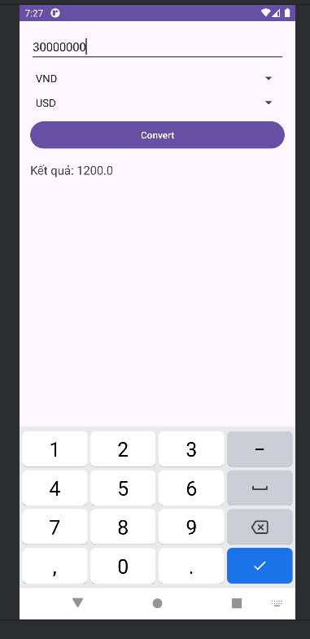

**Chuyển đổi đơn vị độ dài**

**Đầu tiên ta tạo file xml activity_length.xml**

<?xml version="1.0" encoding="utf-8"?>  
<LinearLayout xmlns:android="http://schemas.android.com/apk/res/android"  
 android:orientation="vertical"  
 android:padding="16dp"  
 android:layout_width="match_parent"  
 android:layout_height="match_parent">  
  
 <EditText  
 android:id="@+id/edtValue"  
 android:layout_width="match_parent"  
 android:layout_height="wrap_content"  
 android:hint="Nhập giá trị"  
 android:inputType="numberDecimal" />  
  
 <Spinner  
 android:id="@+id/spUnitFrom"  
 android:layout_width="match_parent"  
 android:layout_height="wrap_content"  
 android:layout_marginTop="12dp" />  
  
 <Spinner  
 android:id="@+id/spUnitTo"  
 android:layout_width="match_parent"  
 android:layout_height="wrap_content"  
 android:layout_marginTop="8dp" />  
  
 <Button  
 android:id="@+id/btnConvert"  
 android:layout_width="match_parent"  
 android:layout_height="wrap_content"  
 android:text="Convert"  
 android:onClick="convert"  
 android:layout_marginTop="12dp" />  
  
 <TextView  
 android:id="@+id/tvOutput"  
 android:layout_width="match_parent"  
 android:layout_height="wrap_content"  
 android:text="Kết quả:"  
 android:textSize="18sp"  
 android:layout_marginTop="16dp" />  
</LinearLayout>

**Ta tạo file MainActivityLength.java**  
**Khai báo biến:**

Spinner spUnitFrom, spUnitTo;  
EditText edtValue;  
TextView tvOutput;  
  
String[] units = {"m", "cm", "inch", "foot"};  
  
double[][] lenRate = {  
 {1.0, 100.0, 39.37, 3.28},  
 {0.01, 1.0, 0.3937, 0.0328},  
 {0.0254, 2.54, 1.0, 0.083333},  
 {0.3048, 30.48, 12.0, 1.0}  
};  
  
int from = 0, to = 0;

**Phần gọi giao diện ra để hiển thị:**

@Override  
protected void onCreate(Bundle savedInstanceState) {  
 super.onCreate(savedInstanceState);  
 setContentView(R.layout.*activity_length*);  
  
 spUnitFrom = findViewById(R.id.*spUnitFrom*);  
 spUnitTo = findViewById(R.id.*spUnitTo*);  
 edtValue = findViewById(R.id.*edtValue*);  
 tvOutput = findViewById(R.id.*tvOutput*);  
  
 ArrayAdapter<String> adapter =  
 new ArrayAdapter<>(this, android.R.layout.*simple_spinner_item*, units);  
 adapter.setDropDownViewResource(android.R.layout.*simple_spinner_dropdown_item*);  
  
 spUnitFrom.setAdapter(adapter);  
 spUnitTo.setAdapter(adapter);  
  
 spUnitFrom.setOnItemSelectedListener(new AdapterView.OnItemSelectedListener() {  
 @Override public void onItemSelected(AdapterView<?> parent, View view, int position, long id) {  
 from = position;  
 }  
 @Override public void onNothingSelected(AdapterView<?> parent) {}  
 });  
  
 spUnitTo.setOnItemSelectedListener(new AdapterView.OnItemSelectedListener() {  
 @Override public void onItemSelected(AdapterView<?> parent, View view, int position, long id) {  
 to = position;  
 }  
 @Override public void onNothingSelected(AdapterView<?> parent) {}  
 });  
}

**Hàm xử lý việc chuyển đổi:**

public void convert(View v) {  
 String s = edtValue.getText().toString().trim();  
 if (s.isEmpty()) {  
 tvOutput.setText("Chưa nhập giá trị!");  
 return;  
 }  
  
 double input;  
 try {  
 input = Double.*parseDouble*(s);  
 } catch (NumberFormatException ex) {  
 tvOutput.setText("Giá trị không hợp lệ!");  
 return;  
 }  
  
 double result = input * lenRate[from][to];  
 tvOutput.setText(String.*format*("%s %s = %.6f %s", s, units[from], result, units[to]));  
}

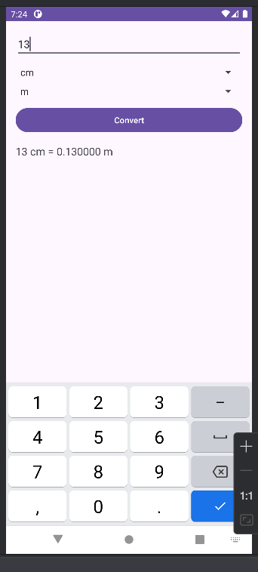

## **Lab7:**

### Bài 1: Sử dụng Custom Button, thiết kế giao diện

**Code theo giao diện:**

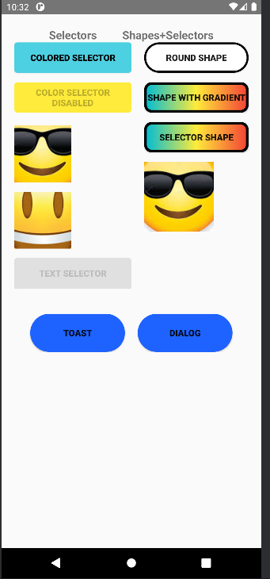

**File xml**

<ScrollView xmlns:android="http://schemas.android.com/apk/res/android"  
 android:layout_width="match_parent"  
 android:layout_height="match_parent">  
  
 <LinearLayout  
 android:layout_width="match_parent"  
 android:layout_height="wrap_content"  
 android:orientation="vertical"  
 android:padding="20dp">  
  
  
 <LinearLayout  
 android:layout_width="match_parent"  
 android:layout_height="wrap_content"  
 android:gravity="center">  
  
 <TextView  
 android:layout_width="wrap_content"  
 android:layout_height="wrap_content"  
 android:text="Selectors"  
 android:textStyle="bold"  
 android:textSize="18sp" />  
  
 <View  
 android:layout_width="40dp"  
 android:layout_height="1dp" />  
  
 <TextView  
 android:layout_width="wrap_content"  
 android:layout_height="wrap_content"  
 android:text="Shapes+Selectors"  
 android:textStyle="bold"  
 android:textSize="18sp" />  
 </LinearLayout>  
  
 <LinearLayout  
 android:layout_width="match_parent"  
 android:layout_height="wrap_content"  
 android:orientation="horizontal"  
 android:weightSum="2">  
  
   
 <LinearLayout  
 android:layout_width="0dp"  
 android:layout_height="wrap_content"  
 android:orientation="vertical"  
 android:layout_weight="1">  
 <Button  
 android:id="@+id/btnColorSelector"  
 android:layout_width="match_parent"  
 android:layout_height="wrap_content"  
 android:background="@drawable/colored_selector"  
 android:text="COLORED SELECTOR"  
 android:textStyle="bold"  
 android:textColor="#000" />  
  
 <Button  
 android:id="@+id/btnDisabled"  
 android:layout_width="match_parent"  
 android:layout_height="wrap_content"  
 android:text="COLOR SELECTOR DISABLED"  
 android:textStyle="bold"  
 android:enabled="false"  
 android:layout_marginTop="15dp"  
 android:background="@drawable/selector_disabled" />  
  
   
 <ImageButton  
 android:id="@+id/btnEmoji1"  
 android:layout_width="90dp"  
 android:layout_height="90dp"  
 android:src="@drawable/emoji"  
 android:background="@drawable/emoji_border"  
 android:layout_marginTop="20dp" />  
  
 <ImageButton  
 android:id="@+id/btnEmoji2"  
 android:layout_width="90dp"  
 android:layout_height="90dp"  
 android:src="@drawable/emoji1"  
 android:background="@drawable/emoji_border"  
 android:layout_marginTop="15dp" />  
  
 <Button  
 android:id="@+id/btnTextSelector"  
 android:layout_width="match_parent"  
 android:layout_height="wrap_content"  
 android:text="TEXT SELECTOR"  
 android:textStyle="bold"  
 android:textColor="@drawable/text_selector"  
 android:layout_marginTop="15dp"  
 android:background="@drawable/text_bg" />  
  
 </LinearLayout>  
  
   
 <LinearLayout  
 android:layout_width="0dp"  
 android:layout_height="wrap_content"  
 android:orientation="vertical"  
 android:layout_weight="1"  
 android:paddingLeft="20dp">  
 <Button  
 android:id="@+id/btnRoundShape"  
 android:layout_width="match_parent"  
 android:layout_height="wrap_content"  
 android:text="ROUND SHAPE"  
 android:background="@drawable/shape_round"  
 android:textStyle="bold" />  
  
 <Button  
 android:id="@+id/btnGradient"  
 android:layout_width="match_parent"  
 android:layout_height="wrap_content"  
 android:text="SHAPE WITH GRADIENT"  
 android:background="@drawable/shape_gradient_big"  
 android:textStyle="bold"  
 android:layout_marginTop="15dp" />  
  
   
 <Button  
 android:id="@+id/btnSelectorShape"  
 android:layout_width="match_parent"  
 android:layout_height="wrap_content"  
 android:text="SELECTOR SHAPE"  
 android:background="@drawable/selector_shape_big"  
 android:textStyle="bold"  
 android:layout_marginTop="15dp" />  
  
  
 <ImageButton  
 android:id="@+id/btnEmoji3"  
 android:layout_width="110dp"  
 android:layout_height="110dp"  
 android:layout_marginTop="15dp"  
 android:src="@drawable/emoji"  
 android:background="@drawable/emoji_border" />  
  
 </LinearLayout>  
 </LinearLayout>  
 <LinearLayout  
 android:layout_width="match_parent"  
 android:layout_height="wrap_content"  
 android:orientation="horizontal"  
 android:gravity="center"  
 android:layout_marginTop="40dp">  
  
 <Button  
 android:id="@+id/btnToast"  
 android:layout_width="150dp"  
 android:layout_height="60dp"  
 android:text="TOAST"  
 android:textStyle="bold"  
 android:background="@drawable/shape_toast_button"/>  
  
 <Button  
 android:id="@+id/btnDialog"  
 android:layout_width="150dp"  
 android:layout_height="60dp"  
 android:text="DIALOG"  
 android:layout_marginLeft="20dp"  
 android:textStyle="bold"  
 android:background="@drawable/shape_toast_button"/>  
 </LinearLayout>  
 </LinearLayout>  
</ScrollView>

### Bài 2: dựa trên bài 1 làm các animation cho các ảnh, tạo ra 1 giao diện đăng nhập cơ bản

**Giao diện**

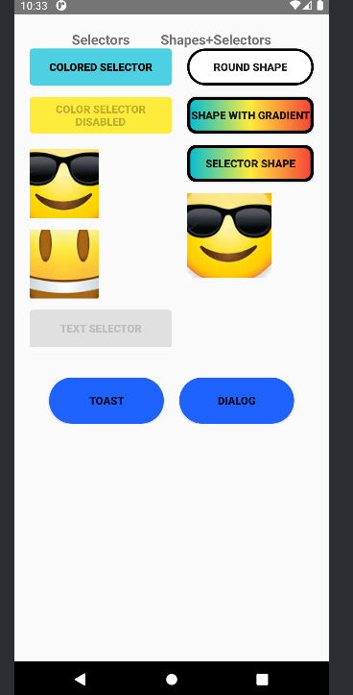

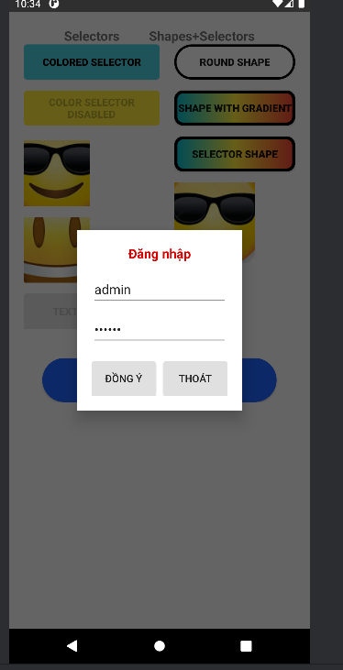

**Drawable**

**Các drawtable:**

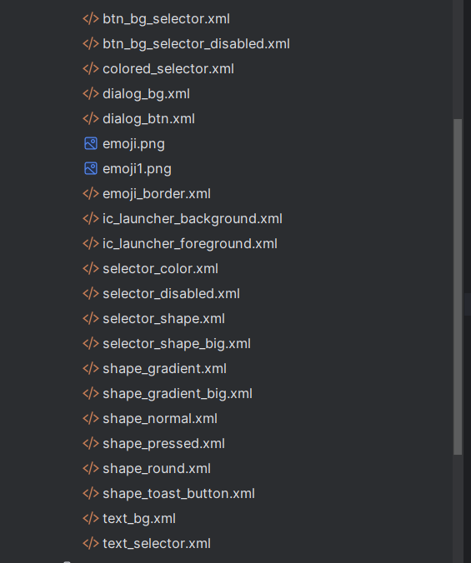

**Layout**

<ScrollView xmlns:android="http://schemas.android.com/apk/res/android"  
 android:layout_width="match_parent"  
 android:layout_height="match_parent">  
  
 <LinearLayout  
 android:layout_width="match_parent"  
 android:layout_height="wrap_content"  
 android:orientation="vertical"  
 android:padding="20dp">  
 <LinearLayout  
 android:layout_width="match_parent"  
 android:layout_height="wrap_content"  
 android:gravity="center">  
  
 <TextView  
 android:layout_width="wrap_content"  
 android:layout_height="wrap_content"  
 android:text="Selectors"  
 android:textStyle="bold"  
 android:textSize="18sp" />  
  
 <View  
 android:layout_width="40dp"  
 android:layout_height="1dp" />  
  
 <TextView  
 android:layout_width="wrap_content"  
 android:layout_height="wrap_content"  
 android:text="Shapes+Selectors"  
 android:textStyle="bold"  
 android:textSize="18sp" />  
 </LinearLayout>  
  
 <LinearLayout  
 android:layout_width="match_parent"  
 android:layout_height="wrap_content"  
 android:orientation="horizontal"  
 android:weightSum="2">  
  
   
 <LinearLayout  
 android:layout_width="0dp"  
 android:layout_height="wrap_content"  
 android:orientation="vertical"  
 android:layout_weight="1">  
  
   
 <Button  
 android:id="@+id/btnColorSelector"  
 android:layout_width="match_parent"  
 android:layout_height="wrap_content"  
 android:background="@drawable/colored_selector"  
 android:text="COLORED SELECTOR"  
 android:textStyle="bold"  
 android:textColor="#000" />  
 <Button  
 android:id="@+id/btnDisabled"  
 android:layout_width="match_parent"  
 android:layout_height="wrap_content"  
 android:text="COLOR SELECTOR DISABLED"  
 android:textStyle="bold"  
 android:enabled="false"  
 android:layout_marginTop="15dp"  
 android:background="@drawable/selector_disabled" />  
  
   
 <ImageButton  
 android:id="@+id/btnEmoji1"  
 android:layout_width="90dp"  
 android:layout_height="90dp"  
 android:src="@drawable/emoji"  
 android:background="@drawable/emoji_border"  
 android:layout_marginTop="20dp" />  
  
 <ImageButton  
 android:id="@+id/btnEmoji2"  
 android:layout_width="90dp"  
 android:layout_height="90dp"  
 android:src="@drawable/emoji1"  
 android:background="@drawable/emoji_border"  
 android:layout_marginTop="15dp" />  
 <Button  
 android:id="@+id/btnTextSelector"  
 android:layout_width="match_parent"  
 android:layout_height="wrap_content"  
 android:text="TEXT SELECTOR"  
 android:textStyle="bold"  
 android:textColor="@drawable/text_selector"  
 android:layout_marginTop="15dp"  
 android:background="@drawable/text_bg" />  
  
 </LinearLayout>  
  
  
 <LinearLayout  
 android:layout_width="0dp"  
 android:layout_height="wrap_content"  
 android:orientation="vertical"  
 android:layout_weight="1"  
 android:paddingLeft="20dp">  
  
  
 <Button  
 android:id="@+id/btnRoundShape"  
 android:layout_width="match_parent"  
 android:layout_height="wrap_content"  
 android:text="ROUND SHAPE"  
 android:background="@drawable/shape_round"  
 android:textStyle="bold" />  
  
   
 <Button  
 android:id="@+id/btnGradient"  
 android:layout_width="match_parent"  
 android:layout_height="wrap_content"  
 android:text="SHAPE WITH GRADIENT"  
 android:background="@drawable/shape_gradient_big"  
 android:textStyle="bold"  
 android:layout_marginTop="15dp" />  
  
  
 <Button  
 android:id="@+id/btnSelectorShape"  
 android:layout_width="match_parent"  
 android:layout_height="wrap_content"  
 android:text="SELECTOR SHAPE"  
 android:background="@drawable/selector_shape_big"  
 android:textStyle="bold"  
 android:layout_marginTop="15dp" />  
 <ImageButton  
 android:id="@+id/btnEmoji3"  
 android:layout_width="110dp"  
 android:layout_height="110dp"  
 android:layout_marginTop="15dp"  
 android:src="@drawable/emoji"  
 android:background="@drawable/emoji_border" />  
  
 </LinearLayout>  
 </LinearLayout>  
 <LinearLayout  
 android:layout_width="match_parent"  
 android:layout_height="wrap_content"  
 android:orientation="horizontal"  
 android:gravity="center"  
 android:layout_marginTop="40dp">  
  
 <Button  
 android:id="@+id/btnToast"  
 android:layout_width="150dp"  
 android:layout_height="60dp"  
 android:text="TOAST"  
 android:textStyle="bold"  
 android:background="@drawable/shape_toast_button"/>  
  
 <Button  
 android:id="@+id/btnDialog"  
 android:layout_width="150dp"  
 android:layout_height="60dp"  
 android:text="DIALOG"  
 android:layout_marginLeft="20dp"  
 android:textStyle="bold"  
 android:background="@drawable/shape_toast_button"/>  
 </LinearLayout>  
 </LinearLayout>  
  
  
</ScrollView>

**Code Activity**

**Code Bai2activtity**

package com.example.lab7;  
  
import android.app.Dialog;  
import android.os.Bundle;  
import android.view.Gravity;  
import android.view.LayoutInflater;  
import android.view.View;  
import android.view.animation.Animation;  
import android.view.animation.AnimationUtils;  
import android.widget.Button;  
import android.widget.EditText;  
import android.widget.LinearLayout;  
import android.widget.TextView;  
import android.widget.Toast;  
  
import androidx.appcompat.app.AppCompatActivity;  
  
public class Bai2Activity extends AppCompatActivity {  
  
 Animation animBounce, animFade, animRotate;  
  
 @Override  
 protected void onCreate(Bundle savedInstanceState) {  
 super.onCreate(savedInstanceState);  
 setContentView(R.layout.activity_bai2);  
  
   
 animBounce = AnimationUtils.loadAnimation(this, R.anim.btn_bounce);  
 animFade = AnimationUtils.loadAnimation(this, R.anim.btn_fade_color);  
 animRotate = AnimationUtils.loadAnimation(this, R.anim.btn_rotate);  
  
   
 setAction(R.id.btnColorSelector, animBounce);  
 setAction(R.id.btnDisabled, animFade);  
 setAction(R.id.btnTextSelector, animFade);  
 setAction(R.id.btnRoundShape, animBounce);  
 setAction(R.id.btnGradient, animRotate);  
 setAction(R.id.btnSelectorShape, animBounce);  
  
 setAction(R.id.btnEmoji1, animRotate);  
 setAction(R.id.btnEmoji2, animBounce);  
 setAction(R.id.btnEmoji3, animRotate);  
  
  
 findViewById(R.id.btnToast).setOnClickListener(v -> showCustomToast());  
  
  
 findViewById(R.id.btnDialog).setOnClickListener(v -> showCustomDialog());  
 }  
  
  
 private void setAction(int id, Animation anim) {  
 View v = findViewById(id);  
 if (v == null) return;  
  
 v.setOnClickListener(x -> {  
 v.startAnimation(anim);  
 });  
 }  
  
 private void showCustomToast() {  
 LayoutInflater inflater = getLayoutInflater();  
 View layout = inflater.inflate(R.layout.custom_toast, null);  
  
 Toast toast = new Toast(getApplicationContext());  
 toast.setDuration(Toast.LENGTH_LONG);  
 toast.setGravity(Gravity.CENTER_HORIZONTAL | Gravity.BOTTOM, 0, 200);  
 toast.setView(layout);  
 toast.show();  
 }  
  
   
 private void showCustomDialog() {  
 Dialog dialog = new Dialog(this);  
 dialog.setContentView(R.layout.custom_dialog);  
 dialog.setCancelable(true);  
  
 EditText edtUser = dialog.findViewById(R.id.edtUser);  
 EditText edtPass = dialog.findViewById(R.id.edtPass);  
 Button btnOK = dialog.findViewById(R.id.btnOK);  
 Button btnCancel = dialog.findViewById(R.id.btnCancel);  
  
 btnOK.setOnClickListener(v -> {  
 Toast.makeText(this,  
 "User: " + edtUser.getText() + "\nPass: " + edtPass.getText(),  
 Toast.LENGTH_LONG).show();  
 });  
  
 btnCancel.setOnClickListener(v -> dialog.dismiss());  
  
 dialog.show();  
 }  
}

### Bài 3: tạo các 1 layout chỉnh các màu theo giao diện đã cho

**Giao diện:**

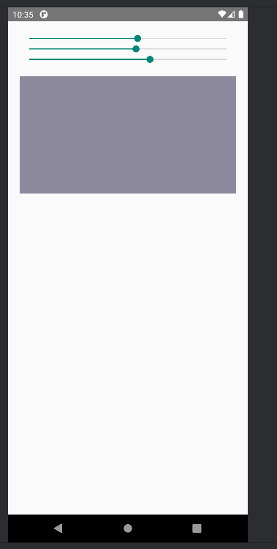

**File xml:**

<LinearLayout xmlns:android="http://schemas.android.com/apk/res/android"  
 android:layout_width="match_parent"  
 android:layout_height="match_parent"  
 android:orientation="vertical"  
 android:padding="20dp">  
  
 <SeekBar  
 android:id="@+id/seekR"  
 android:layout_width="match_parent"  
 android:layout_height="wrap_content"  
 android:max="255" />  
  
 <SeekBar  
 android:id="@+id/seekG"  
 android:layout_width="match_parent"  
 android:layout_height="wrap_content"  
 android:max="255" />  
  
 <SeekBar  
 android:id="@+id/seekB"  
 android:layout_width="match_parent"  
 android:layout_height="wrap_content"  
 android:max="255" />  
  
 <View  
 android:id="@+id/viewColor"  
 android:layout_width="match_parent"  
 android:layout_height="200dp"  
 android:layout_marginTop="20dp"  
 android:background="#000000" />  
  
</LinearLayout>

**Code Activity:**

**Khai báo biến và gọi giao diện:**

SeekBar seekR, seekG, seekB;  
View viewColor;  
@Override  
protected void onCreate(Bundle savedInstanceState) {  
 super.onCreate(savedInstanceState);  
 setContentView(R.layout.*activity_bai3*);  
  
  
 seekR = findViewById(R.id.*seekR*);  
 seekG = findViewById(R.id.*seekG*);  
 seekB = findViewById(R.id.*seekB*);  
 viewColor = findViewById(R.id.*viewColor*);  
  
  
 SeekBar.OnSeekBarChangeListener listener = new SeekBar.OnSeekBarChangeListener() {  
 @Override  
 public void onProgressChanged(SeekBar seekBar, int i, boolean b) {  
 updateColor();  
 }  
 @Override public void onStartTrackingTouch(SeekBar seekBar) {}  
 @Override public void onStopTrackingTouch(SeekBar seekBar) {}  
 };  
  
 seekR.setOnSeekBarChangeListener(listener);  
 seekG.setOnSeekBarChangeListener(listener);  
 seekB.setOnSeekBarChangeListener(listener);  
}

**Update màu:**

private void updateColor() {  
 int r = seekR.getProgress();  
 int g = seekG.getProgress();  
 int b = seekB.getProgress();  
  
  
 viewColor.setBackgroundColor(Color.*rgb*(r, g, b));  
}

## Lab8:

### Bài 1 & 2: Sử dụng Custom Listview, Custom GridView,

**Ta tạo các file java model Contributor và Food để lưu các biến**

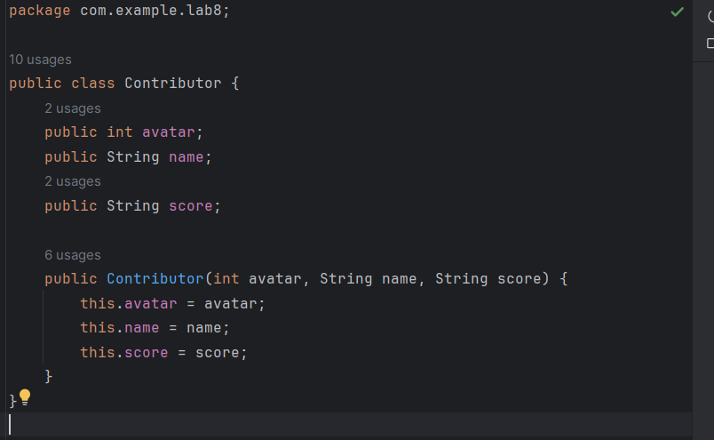

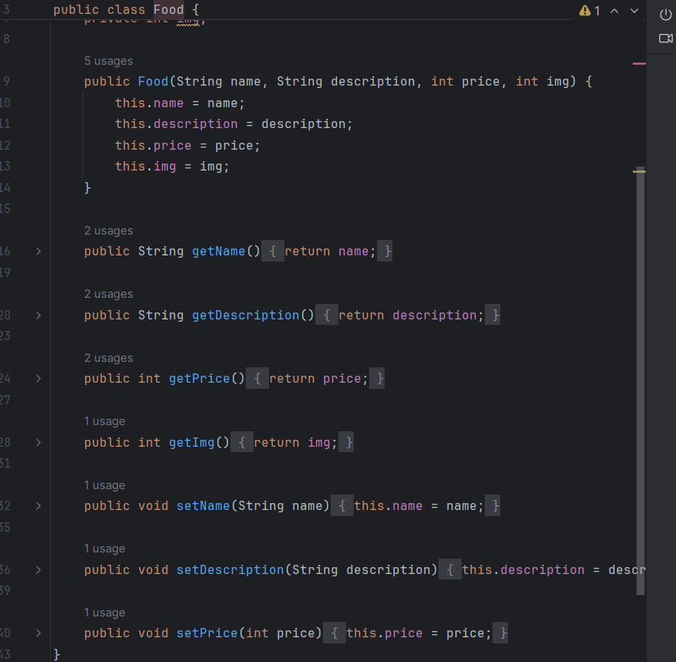

Sau đó ta cần các file adapter để gọi các giá trị này lên các file xml:

ContributorAdapter

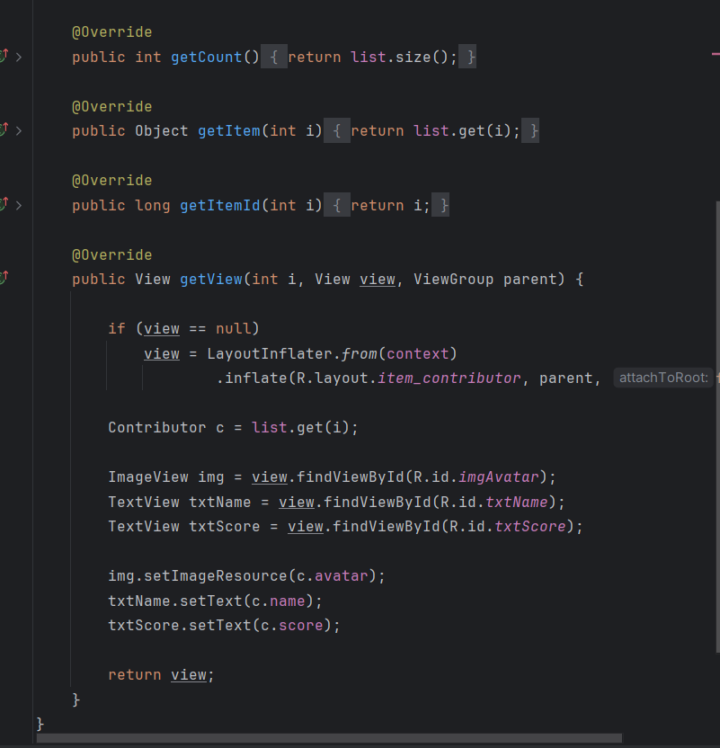

FoodAdapter:

qqqqqqqqqqqqqqq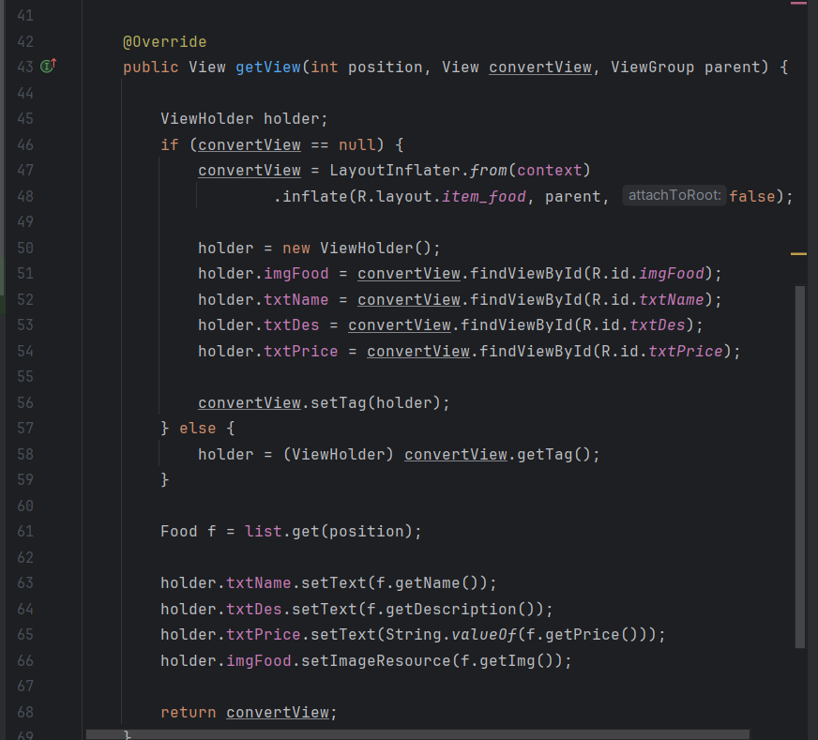

File ListActivity.java để gọi giao diện và hiển thị các ảnh đã thêm vào mục drawtable:

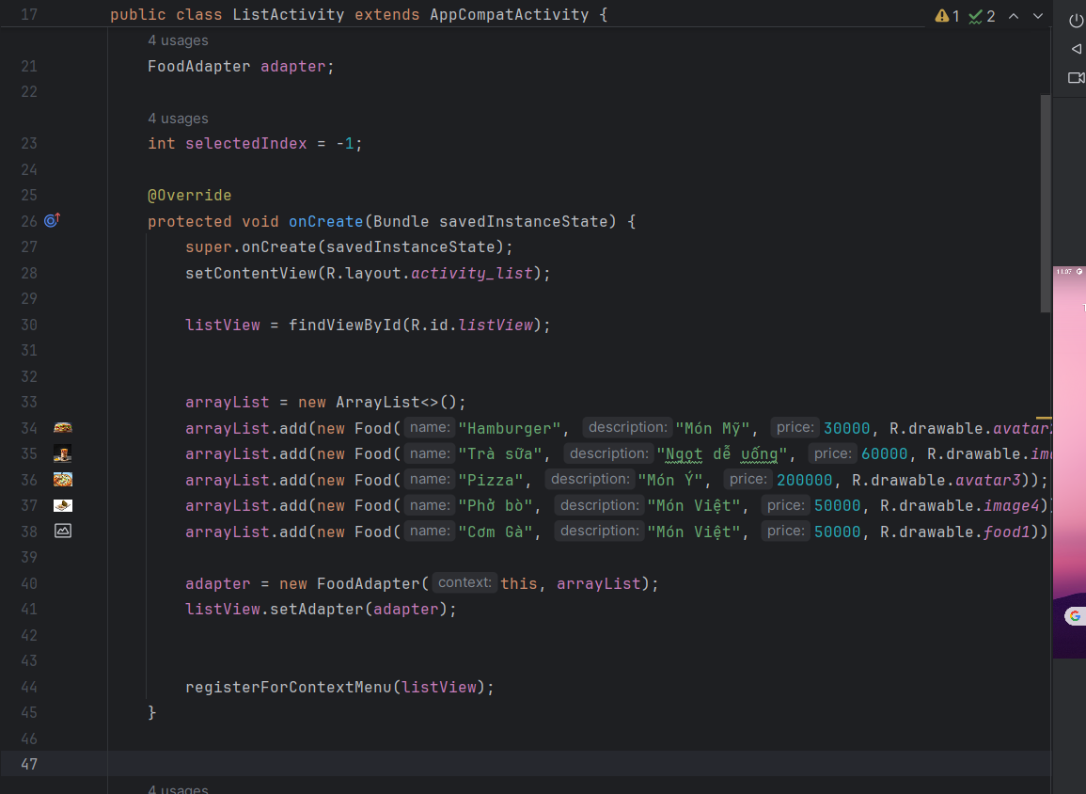

Các file xml:

**activity_grid**

<?xml version="1.0" encoding="utf-8"?>  
<GridView xmlns:android="http://schemas.android.com/apk/res/android"  
 android:id="@+id/gridContributors"  
 android:layout_width="match_parent"  
 android:layout_height="match_parent"  
 android:background="#FFFF"  
 android:numColumns="2"  
 android:horizontalSpacing="10dp"  
 android:verticalSpacing="10dp"  
 android:padding="10dp">  
</GridView>

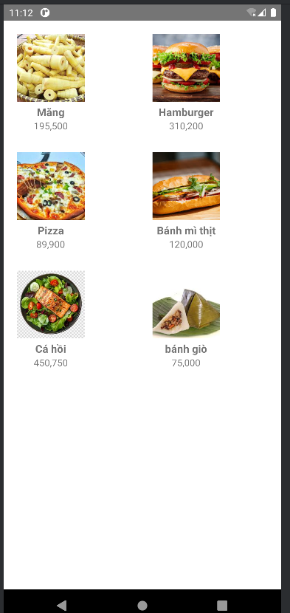

**activity_list**

<?xml version="1.0" encoding="utf-8"?>  
<LinearLayout xmlns:android="http://schemas.android.com/apk/res/android"  
 android:orientation="vertical"  
 android:padding="10dp"  
 android:layout_width="match_parent"  
 android:layout_height="match_parent">  
  
 <ListView  
 android:id="@+id/listView"  
 android:layout_width="match_parent"  
 android:layout_height="match_parent"  
 android:dividerHeight="10dp"/>  
  
</LinearLayout>

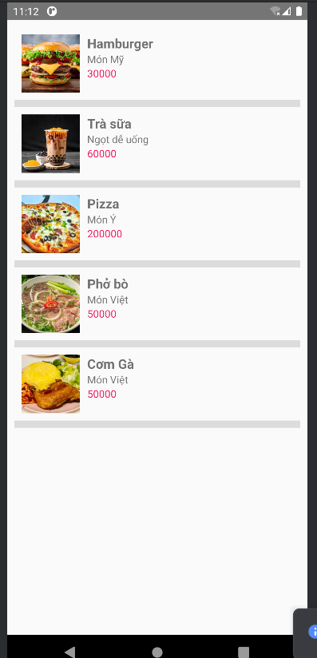

File item_contributor.xml để định dạng các các item trong contributor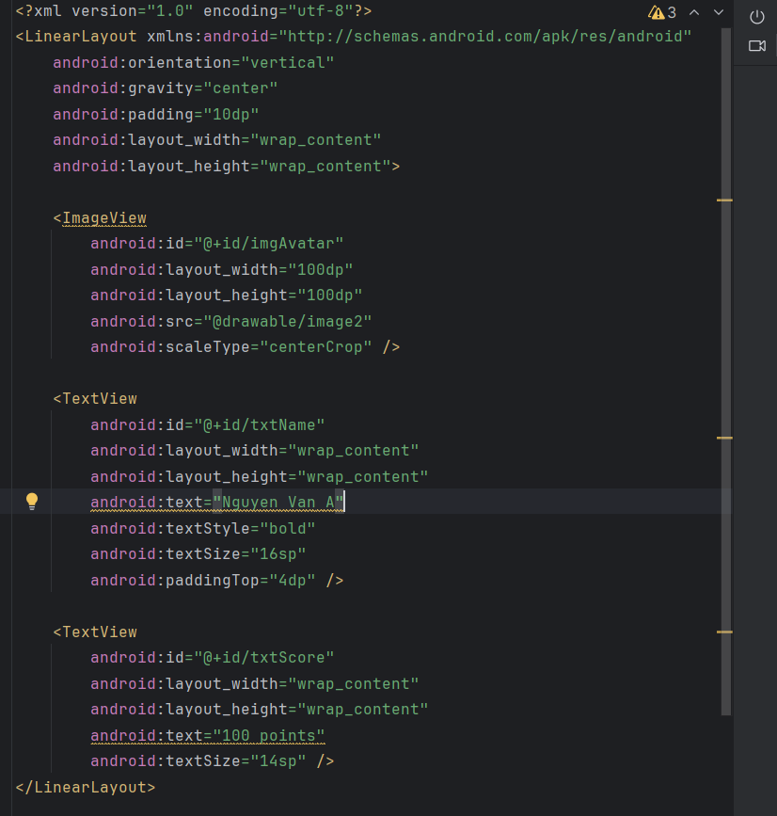

File item_food để định dạng các item trong food

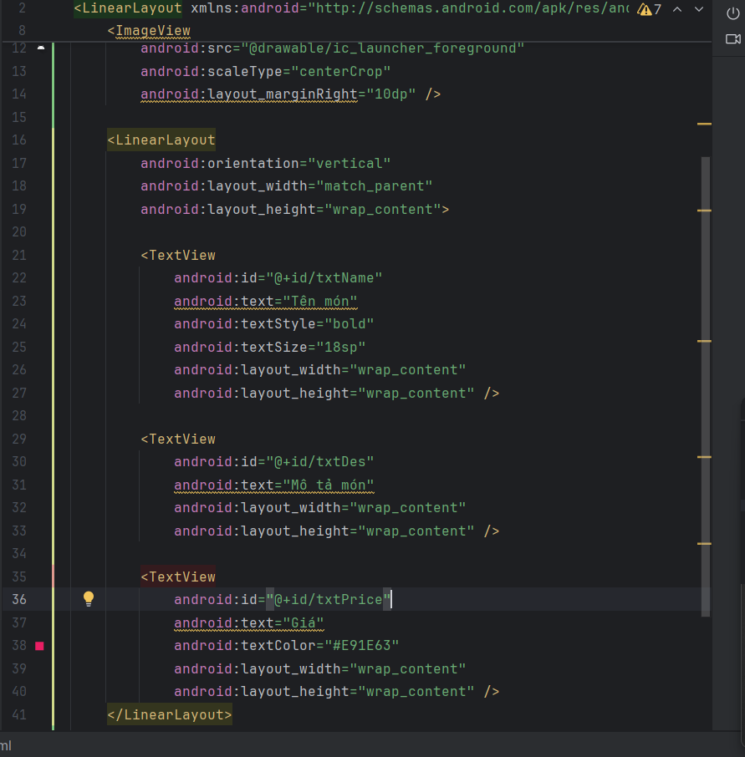

Sửa trong AndroidMainFest.xml

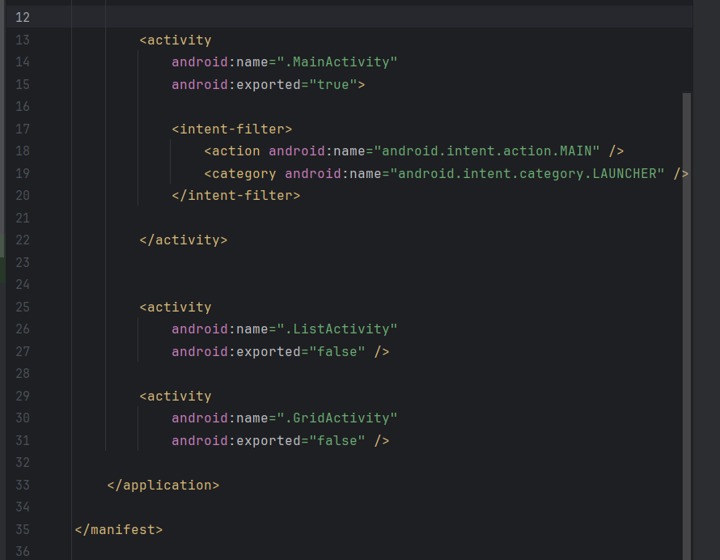

### Bài 3:Thêm tính năng, thêm xóa sửa

Hàm xử lý sửa xóa:

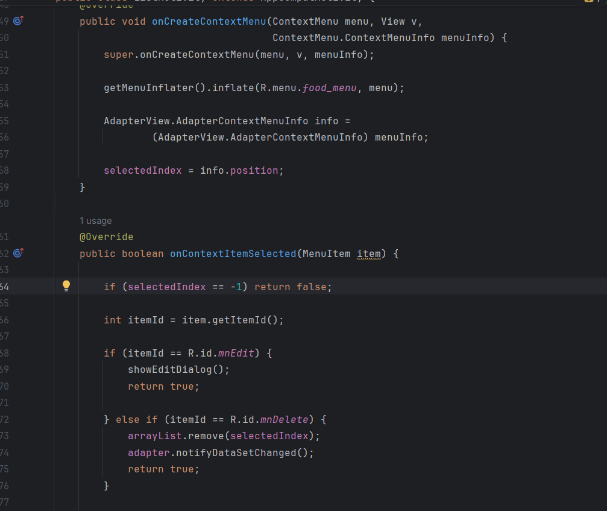

Giao diện sửa:

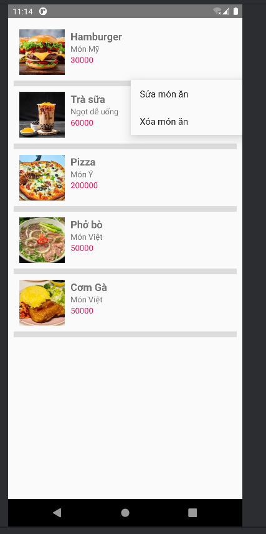

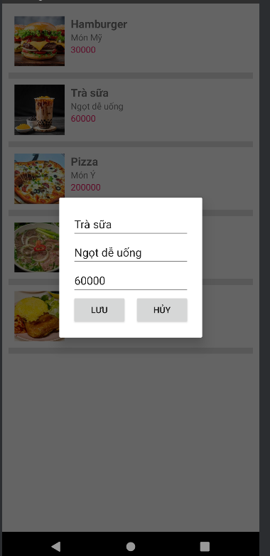

# Lab4

## Lab10:truyện vui dân gian

**1. YÊU CẦU ĐỀ BÀI**

Xây dựng ứng dụng Android hiển thị truyện hài dân gian với các yêu cầu:

- Có 4 màn hình chính:

+ Màn hình Splash (chào mừng, hiển thị 2 giây)

+ Màn hình danh sách chủ đề truyện

+ Màn hình danh sách truyện trong chủ đề

+ Màn hình chi tiết truyện (có thể vuốt trái/phải)

- Giao diện sử dụng theme màu đen

**- Dữ liệu truyện lưu trong file txt**

**BƯỚC 1: CẤU HÌNH RESOURCES**

1.1. Cập nhật file colors.xml

Đường dẫn: app/src/main/res/values/colors.xml

Mục đích: Định nghĩa bảng màu cho theme đen

Code:

```xml

<?xml version="1.0" encoding="utf-8"?>

<resources>

<color name="purple_200">#FFBB86FC</color>

<color name="purple_500">#FF6200EE</color>

<color name="purple_700">#FF3700B3</color>

<color name="teal_200">#FF03DAC5</color>

<color name="teal_700">#FF018786</color>

<color name="black">#FF000000</color>

<color name="white">#FFFFFFFF</color>

<color name="blackMid">#1a1a1a</color>

<color name="blackLight">#2d2d2d</color>

<color name="blackSuperLight">#404040</color>

<color name="gray">#808080</color>

</resources>

**1.2. Cập nhật file strings.xml**

<resources>

<string name="app_name">Truyện Hài dân gian</string>

<string name="txt_congai">Con gái</string>

<string name="txt_story">Vừa đúng vừa sai</string>

</resources>

Tạo các file drawtable

Ic_back



Ic_face

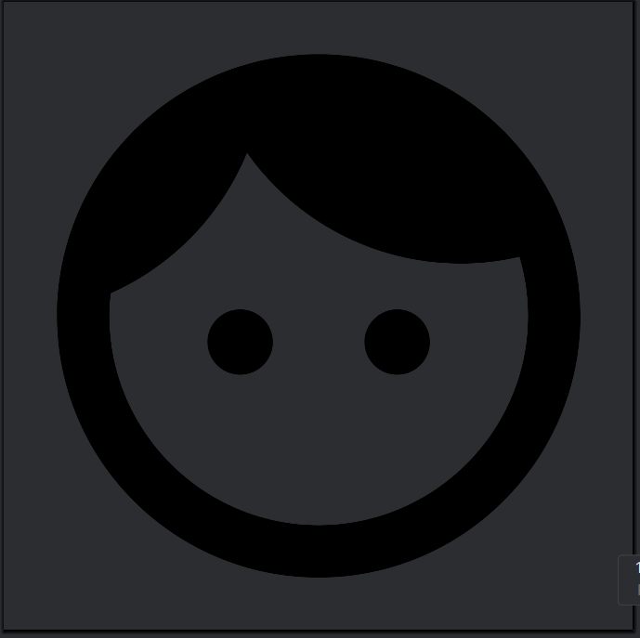

Ic_splash



Tạo các file xml:

File activity_main.xml

Đường dẫn: app/src/main/res/layout/activity_main.xml

Mục đích: Layout chính của MainActivity, chứa container cho Fragment

Code:

```xml

<?xml version="1.0" encoding="utf-8"?>

<LinearLayout xmlns:android="http://schemas.android.com/apk/res/android"

xmlns:tools="http://schemas.android.com/tools"

android:layout_width="match_parent"

android:layout_height="match_parent"

android:id="@+id/ln_main"

tools:context=".MainActivity"

android:orientation="horizontal">

</LinearLayout>

```

**Giải thích:**

- <LinearLayout>: Layout bố trí các view theo hàng dọc/ngang

- android:layout_width="match_parent": Chiều rộng = chiều rộng màn hình

- android:layout_height="match_parent": Chiều cao = chiều cao màn hình

- android:id="@+id/ln_main": ID để tham chiếu trong code

- tools:context=".MainActivity": Liên kết với MainActivity

- android:orientation="horizontal": Bố trí theo chiều ngang

**m000_frg_splash.xml**

<?xml version="1.0" encoding="utf-8"?>

<FrameLayout xmlns:android="http://schemas.android.com/apk/res/android"

xmlns:tools="http://schemas.android.com/tools"

android:layout_width="match_parent"

android:layout_height="match_parent"

android:background="@color/black">

<ImageView

android:layout_width="200dp"

android:layout_height="100dp"

android:layout_gravity="center"

android:src="@drawable/ic_splash"

tools:ignore="ContentDescription" />

</FrameLayout>

Giải thích:

- <FrameLayout>: Layout đơn giản, các view chồng lên nhau

- android:background="@color/black": Nền màu đen

- <ImageView>: Hiển thị ảnh

+ android:layout_width="200dp": Rộng 200dp

+ android:layout_height="100dp": Cao 100dp

+ android:layout_gravity="center": Căn giữa màn hình

+ android:src="@drawable/ic_splash": Nguồn ảnh

+ tools:ignore="ContentDescription": Bỏ qua cảnh báo accessibility

Chức năng:

- Container trống để replace Fragment

- Fragment sẽ được add vào LinearLayout này

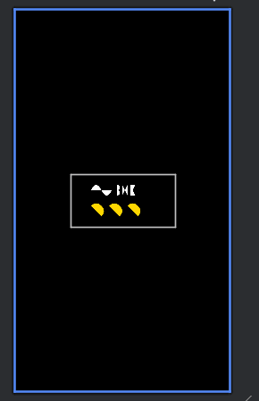

**actionbar_home.xml**

<?xml version="1.0" encoding="utf-8"?>

<LinearLayout

xmlns:android="http://schemas.android.com/apk/res/android"

xmlns:app="http://schemas.android.com/apk/res-auto"

android:layout_width="match_parent"

android:layout_height="56dp"

android:background="@color/blackLight"

android:orientation="horizontal">

<ImageView

android:id="@+id/iv_back"

android:layout_width="56dp"

android:layout_height="56dp"

android:layout_marginStart="10dp"

android:padding="10dp"

android:src="@drawable/ic_back"

android:visibility="gone"

android:clickable="true"

android:focusable="true"

app:tint="@color/white"

android:layout_marginLeft="10dp"

android:contentDescription="Back" />

<TextView

android:id="@+id/tv_name"

android:layout_width="match_parent"

android:layout_height="match_parent"

android:layout_marginStart="10dp"

android:gravity="center_vertical"

android:text="Truyện Hài dân gian"

android:textColor="@color/white"

android:textSize="24sp"

android:layout_marginLeft="10dp" />

</LinearLayout>

Giải thích:

- LinearLayout cao 56dp (chiều cao chuẩn ActionBar)

- android:background="@color/blackLight": Nền màu đen nhạt

- android:orientation="horizontal": Bố trí ngang

ImageView (nút back):

- android:id="@+id/iv_back": ID để tham chiếu

- Kích thước: 56x56dp (vuông)

- android:padding="10dp": Khoảng cách trong

- android:visibility="gone": Ẩn mặc định (hiện khi cần)

- android:clickable="true": Có thể click

- android:focusable="true": Có thể focus

- app:tint="@color/white": Tô màu trắng cho icon

TextView (tiêu đề):

- android:layout_width="match_parent": Chiếm hết chiều rộng còn lại

- android:gravity="center_vertical": Căn giữa theo chiều dọc

- android:textColor="@color/white": Chữ màu trắng

- android:textSize="24sp": Cỡ chữ 24sp

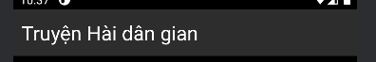

**m001_frg_topic.xml**

<?xml version="1.0" encoding="utf-8"?>

<LinearLayout xmlns:android="http://schemas.android.com/apk/res/android"

android:layout_width="match_parent"

android:layout_height="match_parent"

android:background="@color/black"

android:orientation="vertical">

<include layout="@layout/actionbar_home" />

<ScrollView

android:layout_width="match_parent"

android:layout_height="match_parent">

<LinearLayout

android:id="@+id/ln_topic"

android:layout_width="match_parent"

android:layout_height="wrap_content"

android:orientation="vertical"

android:padding="10dp" />

</ScrollView>

</LinearLayout>

Giải thích:

- LinearLayout ngoài: Bố trí dọc, nền đen

- <include layout="@layout/actionbar_home" />:

+ Nhúng layout actionbar_home vào

+ Tái sử dụng code, không cần viết lại

- <ScrollView>: Cho phép cuộn khi nội dung dài

+ Chỉ chứa được 1 child view

- LinearLayout trong (id="ln_topic"):

+ Container để add các item chủ đề động

+ android:orientation="vertical": Xếp dọc

+ android:padding="10dp": Khoảng cách viền

Chức năng:

- Hiển thị ActionBar

- Danh sách chủ đề có thể cuộn

- Item chủ đề được add động trong code

Chức năng:

- Hiển thị tiêu đề màn hình

- Nút back (ẩn ở màn chủ đề, hiện ở các màn khác)

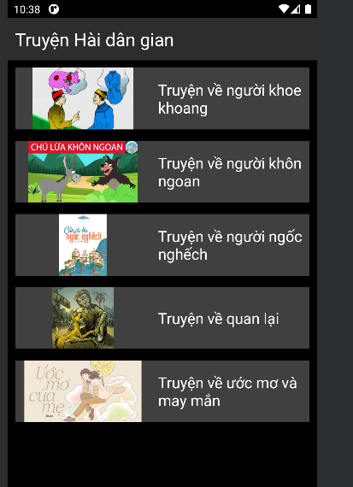

**item_topic.xml**

<?xml version="1.0" encoding="utf-8"?>

<LinearLayout xmlns:android="http://schemas.android.com/apk/res/android"

xmlns:tools="http://schemas.android.com/tools"

android:layout_width="match_parent"

android:layout_height="wrap_content"

android:background="@color/blackSuperLight"

android:layout_marginBottom="10dp"

tools:ignore="UseCompoundDrawables">

<ImageView

android:id="@+id/iv_topic"

android:layout_width="180dp"

android:layout_height="82dp"

android:src="@drawable/ic_launcher_foreground"

tools:ignore="ContentDescription" />

<TextView

android:id="@+id/tv_topic"

android:layout_width="match_parent"

android:layout_height="match_parent"

android:layout_marginStart="10dp"

android:fontFamily="sans-serif"

android:gravity="center_vertical"

android:text="@string/txt_congai"

android:textColor="@color/white"

android:textSize="20sp" />

</LinearLayout>

Giải thích:

- LinearLayout ngang, nền blackSuperLight

- android:layout_marginBottom="10dp": Khoảng cách dưới (giữa các item)

ImageView (ảnh chủ đề):

- Kích thước: 180x82dp (tỷ lệ 2.2:1)

- android:src: Ảnh mặc định (sẽ thay bằng ảnh thật trong code)

TextView (tên chủ đề):

- android:layout_width="match_parent": Chiếm hết chiều rộng còn lại

- android:fontFamily="sans-serif": Font chữ

- android:gravity="center_vertical": Căn giữa dọc

- android:textColor="@color/white": Chữ trắng

- android:textSize="20sp": Cỡ chữ 20sp

Chức năng:

- Hiển thị ảnh và tên chủ đề

- Click vào để xem danh sách truyện

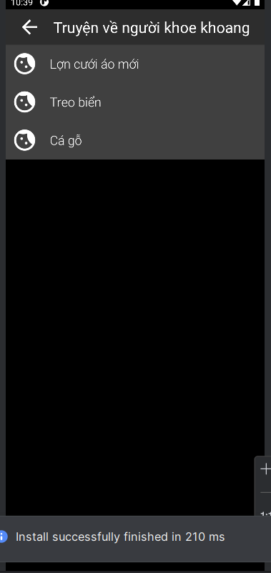

**m002_frg_story.xml**

<?xml version="1.0" encoding="utf-8"?>

<LinearLayout xmlns:android="http://schemas.android.com/apk/res/android"

xmlns:tools="http://schemas.android.com/tools"

android:layout_width="match_parent"

android:layout_height="match_parent"

android:background="@color/black"

android:orientation="vertical">

<include layout="@layout/actionbar_home" />

<androidx.recyclerview.widget.RecyclerView

android:id="@+id/rv_story"

android:layout_width="match_parent"

android:layout_height="match_parent"

tools:listitem="@layout/item_story" />

</LinearLayout>

Giải thích:

- LinearLayout dọc, nền đen

- <include>: Nhúng ActionBar

- <RecyclerView>: Danh sách cuộn hiệu năng cao

+ android:id="@+id/rv_story": ID để tham chiếu

+ tools:listitem="@layout/item_story": Preview item trong Design view

+ Không có ScrollView vì RecyclerView tự cuộn

Ưu điểm RecyclerView:

- Hiệu năng cao (chỉ render item hiển thị trên màn hình)

- Tái sử dụng view (ViewHolder pattern)

- Hỗ trợ animation

- Linh hoạt (LinearLayout, GridLayout, StaggeredGrid)

Chức năng:

- Hiển thị danh sách truyện trong chủ đề

- Cuộn mượt mà

- Click vào truyện để xem chi tiết

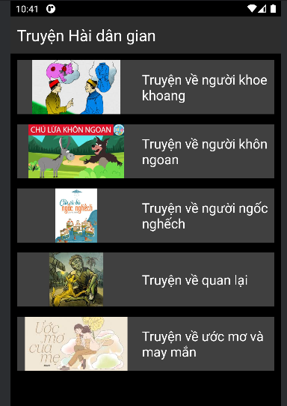

**item_story.xml**

<?xml version="1.0" encoding="utf-8"?>

<LinearLayout xmlns:android="http://schemas.android.com/apk/res/android"

xmlns:app="http://schemas.android.com/apk/res-auto"

xmlns:tools="http://schemas.android.com/tools"

android:layout_width="match_parent"

android:layout_height="wrap_content"

android:background="@color/blackSuperLight"

android:orientation="vertical"

tools:ignore="UseCompoundDrawables">

<TableRow

android:layout_width="match_parent"

android:layout_height="wrap_content">

<ImageView

android:layout_width="60dp"

android:layout_height="60dp"

android:padding="10dp"

android:rotation="45"

android:src="@drawable/ic_face"

app:tint="@color/white"

tools:ignore="ContentDescription" />

<TextView

android:id="@+id/tv_story"

android:layout_width="match_parent"

android:layout_height="match_parent"

android:layout_marginStart="10dp"

android:fontFamily="sans-serif-light"

android:gravity="center_vertical"

android:text="@string/txt_story"

android:textColor="@color/white"

android:textSize="20sp" />

</TableRow

<View

android:layout_width="match_parent"

android:layout_height="0.5dp"

android:background="#404040" />

</LinearLayout>

Giải thích:

- LinearLayout dọc, nền blackSuperLight

- <TableRow>: Bố trí ngang (như LinearLayout horizontal)

+ Dùng để căn chỉnh icon và text

ImageView (icon):

- Kích thước: 60x60dp

- android:rotation="45": Xoay 45 độ (tạo hiệu ứng kim cương)

- app:tint="@color/white": Tô màu trắng

TextView (tên truyện):

- android:fontFamily="sans-serif-light": Font nhẹ

- android:gravity="center_vertical": Căn giữa dọc

<View> (đường kẻ):

- android:layout_height="0.5dp": Đường kẻ mỏng

- android:background="#404040": Màu xám đậm

- Phân cách giữa các item

Chức năng:

- Hiển thị icon và tên truyện

- Đường kẻ phân cách

- Click để xem chi tiết



m003_frg_detail_story.xml

<?xml version="1.0" encoding="utf-8"?>

<LinearLayout xmlns:android="http://schemas.android.com/apk/res/android"

android:layout_width="match_parent"

android:layout_height="match_parent"

android:background="@color/black"

android:orientation="vertical">

<include layout="@layout/actionbar_home" />

<androidx.viewpager.widget.ViewPager

android:id="@+id/vp_story"

android:layout_width="match_parent"

android:layout_height="match_parent" />

</LinearLayout>

Giải thích:

- LinearLayout dọc, nền đen

- <include>: Nhúng ActionBar

- <ViewPager>: Component cho phép vuốt trái/phải

+ android:id="@+id/vp_story": ID để tham chiếu

+ Tự động xử lý gesture vuốt

+ Hiển thị từng page (mỗi page là 1 truyện)

Cách hoạt động ViewPager:

1. Adapter cung cấp số lượng page (getCount)

2. ViewPager tạo view cho page hiện tại và page kế bên

3. Người dùng vuốt → ViewPager animate chuyển page

4. ViewPager hủy view của page xa (tiết kiệm bộ nhớ)

Chức năng:

- Hiển thị chi tiết truyện

- Vuốt trái: Truyện tiếp theo

- Vuốt phải: Truyện trước đó

- Smooth animation

**item_detail_story.xml**

<?xml version="1.0" encoding="utf-8"?>

<LinearLayout xmlns:android="http://schemas.android.com/apk/res/android"

android:layout_width="match_parent"

android:layout_height="match_parent"

android:orientation="vertical"

android:padding="10dp"

android:background="@color/black">

<TextView

android:id="@+id/tv_name"

android:layout_width="match_parent"

android:layout_height="wrap_content"

android:layout_marginTop="20dp"

android:gravity="center"

android:padding="10dp"

android:text="Vừa ăn vừa nói"

android:textColor="@color/white"

android:textSize="24sp"

android:textStyle="bold" />

<ScrollView

android:layout_width="match_parent"

android:layout_height="match_parent">

<LinearLayout

android:layout_width="match_parent"

android:layout_height="wrap_content"

android:orientation="vertical">

<TextView

android:id="@+id/tv_content"

android:layout_width="match_parent"

android:layout_height="wrap_content"

android:fontFamily="sans-serif-light"

android:gravity="center_vertical"

android:lineSpacingExtra="5dp"

android:padding="10dp"

android:text="Nội dung truyện"

android:textColor="@color/white"

android:textSize="18sp" />

</LinearLayout>

</ScrollView>

</LinearLayout>

Giải thích:

- LinearLayout dọc, nền đen, padding 10dp

TextView tên truyện (tv_name):

- android:layout_marginTop="20dp": Khoảng cách trên

- android:gravity="center": Căn giữa

- android:textStyle="bold": Chữ đậm

- android:textSize="24sp": Cỡ chữ lớn

ScrollView:

- Cho phép cuộn nội dung dài

- Chứa LinearLayout (vì ScrollView chỉ chứa 1 child)

TextView nội dung (tv_content):

- android:fontFamily="sans-serif-light": Font nhẹ

- android:lineSpacingExtra="5dp": Khoảng cách dòng (dễ đọc)

- android:textSize="18sp": Cỡ chữ vừa phải

Chức năng:

- Hiển thị tên truyện (bold, căn giữa)

- Hiển thị nội dung truyện (có thể cuộn)

- Dễ đọc với khoảng cách dòng hợp lý



Cấu trúc drawtable và layout

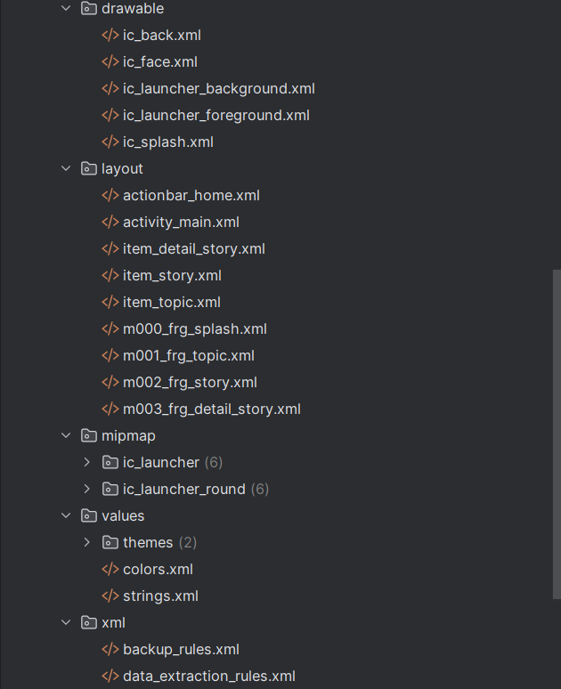

BƯỚC 2: Tạo Java Classes

2.1. StoryEntity.java

- Class đối tượng truyện

- 3 thuộc tính: topicName, name, content

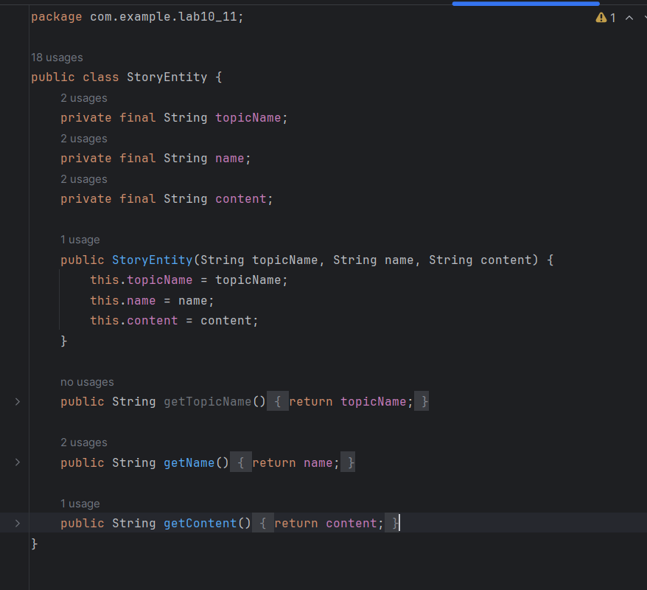

2.2. M000SplashFrg.java

- Fragment splash

- Handler delay 2 giây

public class M000SplashFrg extends Fragment {  
 @Override  
 public View onCreateView(LayoutInflater inflater, ViewGroup container, Bundle savedInstanceState) {  
 initViews();  
 return inflater.inflate(R.layout.*m000_frg_splash*, container, false);  
 }  
 private void initViews() {  
 new Handler().postDelayed(this::gotoM001Screen, 2000);  
 }  
  
 private void gotoM001Screen() {  
 ((MainActivity) getActivity()).gotoM001Screen();  
 }  
}

2.3. M001TopicFrg.java

- Đọc file từ assets/story

private void initViews(View v) {  
 LinearLayout lnMain = v.findViewById(R.id.*ln_topic*);  
 lnMain.removeAllViews();  
  
 try {  
 String[] listItem = mContext.getAssets().list("story");  
 for (String fileName : listItem) {  
 String name = fileName.substring(0, fileName.indexOf("."));  
 View vTopic = LayoutInflater.*from*(mContext).inflate(R.layout.*item_topic*, null);  
 ImageView ivTopic = vTopic.findViewById(R.id.*iv_topic*);  
 TextView tvTopic = vTopic.findViewById(R.id.*tv_topic*);  
  
 String imageFileName = getImageFileName(name);  
 try {  
 ivTopic.setImageBitmap(BitmapFactory  
 .*decodeStream*(mContext.getAssets().open("photo/" + imageFileName)));  
 } catch (Exception e) {  
 e.printStackTrace();  
 }  
  
 tvTopic.setText(name);  
 lnMain.addView(vTopic);  
  
 LinearLayout.LayoutParams params = (LinearLayout.LayoutParams) vTopic.getLayoutParams();  
 params.bottomMargin = 40;  
 vTopic.setLayoutParams(params);  
  
 vTopic.setTag(name);  
 vTopic.setOnClickListener(this);  
 }  
 } catch (Exception e) {  
 e.printStackTrace();  
 }  
}

- Load ảnh từ assets/photo

String imageFileName = getImageFileName(name);  
try {  
 ivTopic.setImageBitmap(BitmapFactory  
 .*decodeStream*(mContext.getAssets().open("photo/" + imageFileName)));  
} catch (Exception e) {  
 e.printStackTrace();  
}

- Hiển thị danh sách chủ đề

private String getImageFileName(String topicName) {  
 if (topicName.contains("khoe khoang")) {  
 return "khoekhoang.png";  
 } else if (topicName.contains("khôn ngoan")) {  
 return "khonngoan.png";  
 } else if (topicName.contains("ngốc nghếch")) {  
 return "ngocnghech.png";  
 } else if (topicName.contains("quan lại")) {  
 return "quanlai.png";  
 } else if (topicName.contains("ước mơ")) {  
 return "uocmo.png";  
 }  
 return "khonngoan.png";  
}

2.4. StoryAdapter.java

- Adapter cho RecyclerView

private final ArrayList<StoryEntity> listStory;  
private final Context mContext;  
public StoryAdapter(ArrayList<StoryEntity> listStory, Context mContext) {  
 this.listStory = listStory;  
 this.mContext = mContext;  
}

- Hiển thị danh sách truyện

@Override  
public StoryHolder onCreateViewHolder(ViewGroup parent, int viewType) {  
 View view = LayoutInflater.*from*(mContext).inflate(R.layout.*item_story*, parent, false);  
 return new StoryHolder(view);  
}  
@Override  
public void onBindViewHolder(StoryAdapter.StoryHolder holder, int position) {  
 StoryEntity item = listStory.get(position);  
 holder.tvName.setTag(item);  
 holder.tvName.setText(item.getName());  
}  
@Override  
public int getItemCount() {  
 return listStory.size();  
}  
  
public class StoryHolder extends RecyclerView.ViewHolder {  
 TextView tvName;  
  
 public StoryHolder(View itemView) {  
 super(itemView);  
 tvName = itemView.findViewById(R.id.*tv_story*);  
 itemView.setOnClickListener(v -> {  
 ((MainActivity) mContext).gotoM003Screen(listStory, (StoryEntity) tvName.getTag());  
 });  
 }  
}

2.5. M002StoryFrg.java

- Đọc và parse file txt

private ArrayList<StoryEntity> readStory() {  
 ArrayList<StoryEntity> listStory = new ArrayList<>();  
 BufferedReader reader = null;  
 try {  
 reader = new BufferedReader(  
 new InputStreamReader(mContext.getAssets().open("story/" + topicName + ".txt"), "UTF-8"));  
 String mLine;  
 do {  
 String title = reader.readLine();  
 if (title == null) break;  
 String content = "";  
 do {  
 mLine = reader.readLine();  
 content += mLine + "\n";  
 } while (!mLine.contains("','0');"));  
 content = content.replace("','0');", "");  
 StoryEntity storyEntity = new StoryEntity(topicName, title, content);  
 listStory.add(storyEntity);  
 } while (mLine != null);  
 } catch (IOException e) {  
 e.printStackTrace();  
 }  
 return listStory;  
}

- Format: Tên truyện + Nội dung + ','0');

try {  
 reader = new BufferedReader(  
 new InputStreamReader(mContext.getAssets().open("story/" + topicName + ".txt"), "UTF-8"));  
 String mLine;  
 do {  
 String title = reader.readLine();  
 if (title == null) break;  
 String content = "";  
 do {  
 mLine = reader.readLine();  
 content += mLine + "\n";  
 } while (!mLine.contains("','0');"));  
 content = content.replace("','0');", "");  
 StoryEntity storyEntity = new StoryEntity(topicName, title, content);  
 listStory.add(storyEntity);  
 } while (mLine != null);  
}

2.6. DetailStoryAdapter.java

- Adapter cho ViewPager

- Cho phép vuốt trái/phải

private final List<StoryEntity> listStory;  
private final Context mContext;  
  
public DetailStoryAdapter(List<StoryEntity> listStory, Context mContext) {  
 this.listStory = listStory;  
 this.mContext = mContext;  
}

2.7. M003DetailStoryFrg.java

- Fragment chi tiết truyện

@Override  
public View onCreateView(LayoutInflater inflater, ViewGroup container, Bundle savedInstanceState) {  
 View rootView = inflater.inflate(R.layout.*m003_frg_detail_story*, container, false);  
 initViews(rootView);  
 return rootView;  
}  
  
@Override  
public void onAttach(Context context) {  
 super.onAttach(context);  
 mContext = context;  
}

- Sử dụng ViewPager

private void initViews(View v) {  
 v.findViewById(R.id.*iv_back*).setVisibility(View.*VISIBLE*);  
 v.findViewById(R.id.*iv_back*).setOnClickListener(v1 -> backToM002Screen());  
  
 ((TextView) v.findViewById(R.id.*tv_name*)).setText(topicName);  
  
 ViewPager vp = v.findViewById(R.id.*vp_story*);  
 DetailStoryAdapter adapter = new DetailStoryAdapter(listStory, mContext);  
 vp.setAdapter(adapter);  
 vp.setCurrentItem(listStory.indexOf(currentStory), true);  
}

2.8. MainActivity.java

- Quản lý chuyển đổi Fragment

private void showFrg(Fragment frg) {  
 getSupportFragmentManager().beginTransaction().replace(R.id.*ln_main*, frg, null).commit();  
}

- 4 phương thức: gotoM001, gotoM002, gotoM003, backToM001

public void gotoM001Screen() {  
 getSupportFragmentManager().beginTransaction().replace(R.id.*ln_main*, new M001TopicFrg(), null).commit();  
 }  
  
 public void gotoM002Screen(String topicName) {  
 this.topicName = topicName;  
 M002StoryFrg frg = new M002StoryFrg();  
 frg.setTopicName(topicName);  
 showFrg(frg);  
 }  
  
 public void backToM001Screen() {  
 gotoM001Screen();  
 }  
  
 public void gotoM003Screen(ArrayList<StoryEntity> listStory, StoryEntity story) {  
 M003DetailStoryFrg frg = new M003DetailStoryFrg();  
 frg.setData(topicName, listStory, story);  
 showFrg(frg);  
 }  
}

Bước 3 :

3.1. Tạo thư mục assets/story

- Chuột phải app/src/main → New → Folder → Assets Folder

3.2. Tạo file "Truyện vui dân gian.txt"

- 10 truyện với format đúng

- Mỗi truyện kết thúc bằng ','0');

3.3. Tạo thư mục assets/photo

- Thêm file dangian.png

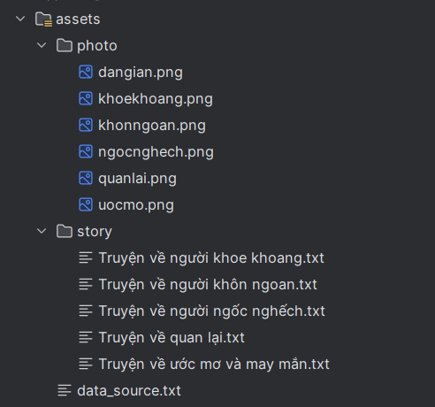

Cấu trúc thư mục class  
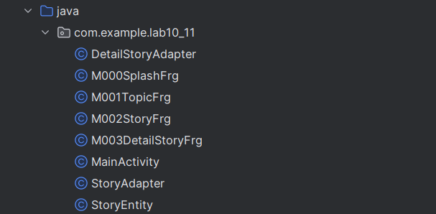

# Lab5

## Bài 13 & 14 Ứng dụng đăng nhập và đăng ký

**Bước 1: Tạo Project Android**

1.1. Mở Android Studio

1.2. Chọn File → New → New Project

1.3. Chọn template "Empty Activity"

1.4. Cấu hình project:

• Name: Lab13_4

• Package name: com.example.lab13_4

• Language: Java

• Minimum SDK: API 21

**Bước 2: Chuẩn bị Resources**

2.1. Tạo file colors.xml

Vị trí: app/src/main/res/values/colors.xml

Mở file và thêm các màu sau:

<color name="orange">#FB8C00</color>  
<color name="gray">#EAE5E3</color>  
<color name="orangeMid">#F4511E</color>  
<color name="black">#FF000000</color>  
<color name="white">#FFFFFFFF</color>

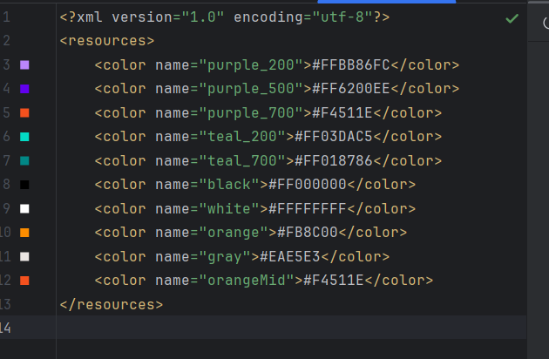

2.2. Tạo file strings.xml

Vị trí: app/src/main/res/values/strings.xml

Thêm các string resource:

<string name="app_name">Login</string>  
<string name="txt_login">Login</string>  
<string name="hint_email">Email</string>  
<string name="hint_password">Password</string>  
<string name="txt_register">Register</string>

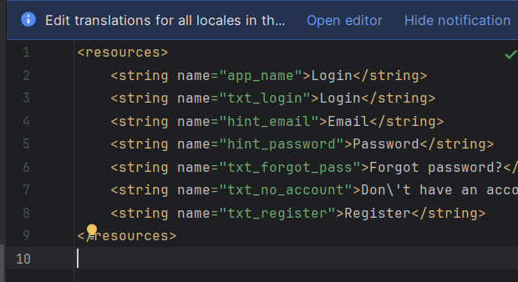

**Bước 3: Tạo Drawable Files**

3.1. Tạo bg_rect.xml

Vị trí: app/src/main/res/drawable/bg_rect.xml

Mục đích: Background gradient màu cam

Click chuột phải vào drawable → New → Drawable Resource File → Tên: bg_rect

<shape xmlns:android="http://schemas.android.com/apk/res/android"  
 android:shape="rectangle">  
 <gradient  
 android:angle="135"  
 android:endColor="#F4511E"  
 android:startColor="#FB8C00"  
 android:type="linear" />  
</shape>

3.2. Tạo bg_top.xml

Mục đích: Background header với góc bo tròn dưới trái

<shape xmlns:android="http://schemas.android.com/apk/res/android">  
 <corners android:bottomLeftRadius="100dp" />  
 <gradient  
 android:angle="145"  
 android:endColor="@color/orange"  
 android:startColor="@color/orangeMid" />  
</shape>

3.3. Tạo bg_radius.xml

Mục đích: Background cho EditText (ô nhập liệu)

<layer-list xmlns:android="http://schemas.android.com/apk/res/android">  
 <item android:drawable="@drawable/bg_rect" />  
 <item android:bottom="3dp">  
 <shape>  
 <corners android:radius="20dp" />  
 <solid android:color="#ffffff" />  
 </shape>  
 </item>  
</layer-list>

3.4. Tạo bg_login.xml

Mục đích: Background cho button Login/Register

<layer-list xmlns:android="http://schemas.android.com/apk/res/android">  
 <item android:drawable="@drawable/bg_rect" />  
 <item android:bottom="3dp">  
 <shape>  
 <corners android:radius="20dp" />  
 <gradient  
 android:angle="180"  
 android:endColor="@color/orange"  
 android:startColor="@color/orangeMid" />  
 </shape>  
 </item>  
</layer-list>

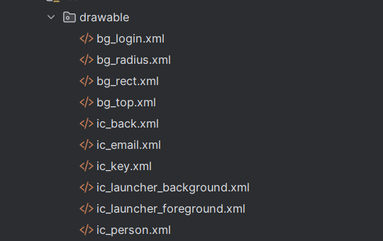

3.5. Tạo các icon vector

Cách tạo: Click chuột phải vào drawable → New → Vector Asset

- ic_email.xml: Chọn icon "mail"

- ic_key.xml: Chọn icon "vpn_key"

- ic_back.xml: Chọn icon "arrow_back"

- ic_person.xml: Chọn icon "person"

**Bước 4: Tạo Layout Files**

4.1. File activity_main.xml

Vị trí: app/src/main/res/layout/activity_main.xml

Mục đích: Layout chính làm container cho Fragment

<LinearLayout xmlns:android="http://schemas.android.com/apk/res/android"  
 android:id="@+id/ln_main"  
 android:layout_width="match_parent"  
 android:layout_height="match_parent"  
 android:orientation="vertical">  
</LinearLayout>

4.2. File m000_frg_login.xml

Vị trí: app/src/main/res/layout/m000_frg_login.xml

Mục đích: Giao diện màn hình đăng nhập

Bao gồm:

- Header với background gradient

- EditText email với icon

- EditText password với icon

- CheckBox Remember Me

- Button Login

- Link đến Register

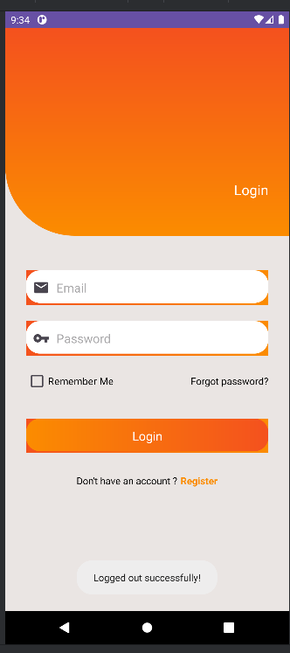

4.3. File m001_frg_register.xml

Vị trí: app/src/main/res/layout/m001_frg_register.xml

Mục đích: Giao diện màn hình đăng ký

Bao gồm:

- Header với nút Back

- EditText email

- EditText password

- EditText re-enter password

- Button Register

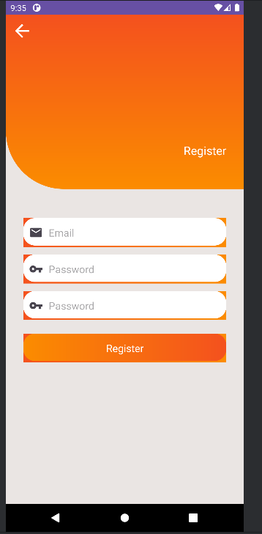

4.4. File m002_frg_home.xml

Vị trí: app/src/main/res/layout/m002_frg_home.xml

Mục đích: Giao diện màn hình Home

Bao gồm:

- Icon person

- TextView "Welcome!"

- TextView hiển thị email user

- Button View All Accounts

- Button Logout

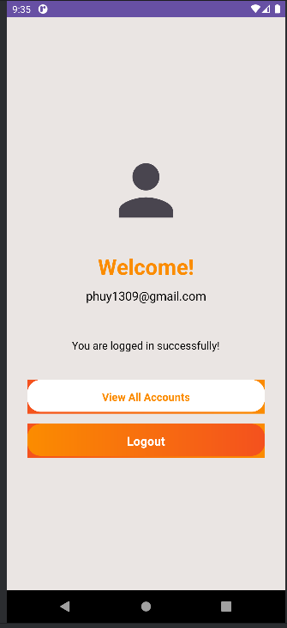

**Bước 5: Tạo DatabaseHelper.java**

Vị trí: app/src/main/java/com/example/lab13_4/DatabaseHelper.java

Mục đích: Quản lý SQLite Database

5.1. Khai báo constants

private static final String DATABASE_NAME = "UserDB.db";  
private static final int DATABASE_VERSION = 1;  
private static final String TABLE_USERS = "users";  
private static final String COL_ID = "id";  
private static final String COL_EMAIL = "email";  
private static final String COL_PASSWORD = "password";  
private static final String COL_IS_LOGGED_IN = "is_logged_in";

5.2. Method onCreate() - Tạo bảng users

@Override  
public void onCreate(SQLiteDatabase db) {  
 String createTable = "CREATE TABLE " + TABLE_USERS + " (" +  
 COL_ID + " INTEGER PRIMARY KEY AUTOINCREMENT, " +  
 COL_EMAIL + " TEXT UNIQUE, " +  
 COL_PASSWORD + " TEXT, " +  
 COL_IS_LOGGED_IN + " INTEGER DEFAULT 0)";  
 db.execSQL(createTable);  
}

5.3. Method registerUser() - Đăng ký user mới

public boolean registerUser(String email, String password) {  
 SQLiteDatabase db = this.getWritableDatabase();  
 if (checkUserExists(email)) {  
 return false;  
 }  
 ContentValues values = new ContentValues();  
 values.put(COL_EMAIL, email);  
 values.put(COL_PASSWORD, password);  
 values.put(COL_IS_LOGGED_IN, 0);  
 long result = db.insert(TABLE_USERS, null, values);  
 return result != -1;  
}

5.4. Method loginUser() - Đăng nhập

public boolean loginUser(String email, String password) {  
 SQLiteDatabase db = this.getWritableDatabase();  
 Cursor cursor = db.query(TABLE_USERS,  
 new String[]{COL_ID},  
 COL_EMAIL + "=? AND " + COL_PASSWORD + "=?",  
 new String[]{email, password},  
 null, null, null);  
 if (cursor.getCount() > 0) {  
 logoutAllUsers();  
 ContentValues values = new ContentValues();  
 values.put(COL_IS_LOGGED_IN, 1);  
 db.update(TABLE_USERS, values, COL_EMAIL + "=?", new String[]{email});  
 cursor.close();  
 return true;  
 }  
 cursor.close();  
 return false;  
}

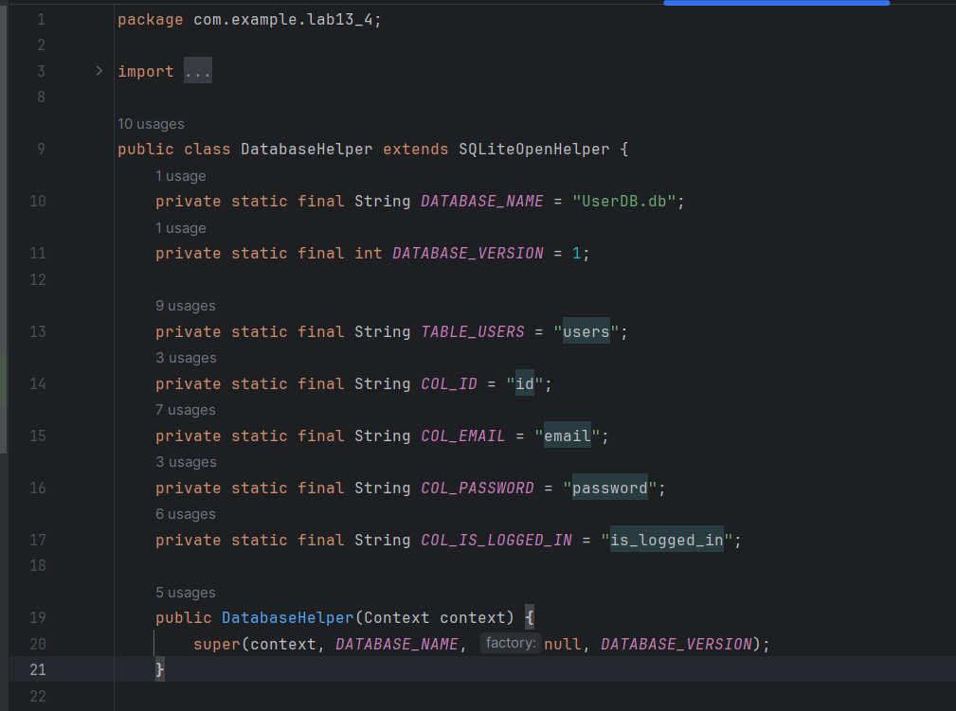

**Bước 6: Tạo PreferenceHelper.java**

Vị trí: app/src/main/java/com/example/lab13_4/PreferenceHelper.java

Mục đích: Quản lý SharedPreferences cho Remember Me

Các method: saveLoginInfo(), getSavedEmail(), getSavedPassword(), clearLoginInfo()

**Bước 7: Tạo AccountManager.java**

Vị trí: app/src/main/java/com/example/lab13_4/AccountManager.java

Mục đích: Quản lý và hiển thị danh sách tài khoản

Các method: getAllAccounts(), exportAccountsToString()

**Bước 8: Tạo Fragment Classes**

8.1. M000LoginFragment.java

Vị trí: app/src/main/java/com/example/lab13_4/M000LoginFragment.java

Chức năng: Xử lý đăng nhập

private void login(String mail, String pass) {  
 if (mail.isEmpty() || pass.isEmpty()) {  
 Toast.makeText(mContext, "Empty value", Toast.LENGTH_SHORT).show();  
 return;  
 }  
 boolean loginSuccess = dbHelper.loginUser(mail, pass);  
 if (loginSuccess) {  
 if (cbRemember.isChecked()) {  
 prefHelper.saveLoginInfo(mail, pass, true);  
 }  
 Toast.makeText(mContext, "Login successfully!", Toast.LENGTH_SHORT).show();  
 ((MainActivity) mContext).gotoHomeScreen();  
 } else {  
 Toast.makeText(mContext, "Email or password incorrect!", Toast.LENGTH_SHORT).show();  
 }  
}

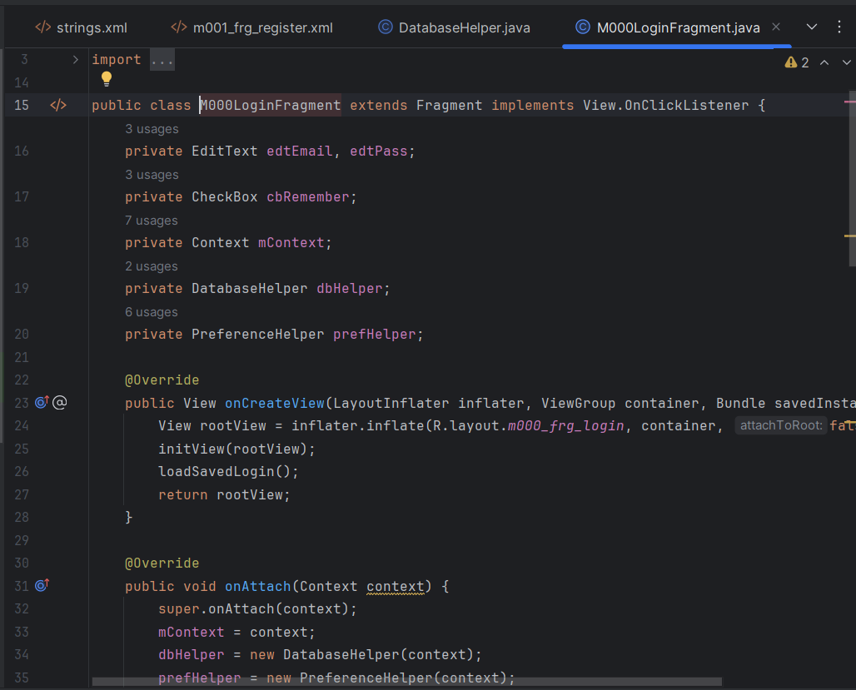

8.2. M001RegisterFragment.java

Vị trí: app/src/main/java/com/example/lab13_4/M001RegisterFragment.java

Chức năng: Xử lý đăng ký

private void register(String mail, String pass, String repass) {  
 if (mail.isEmpty() || pass.isEmpty() || repass.isEmpty()) {  
 Toast.makeText(mContext, "Empty value", Toast.LENGTH_SHORT).show();  
 return;  
 }  
 if (!pass.equals(repass)) {  
 Toast.makeText(mContext, "Password not match", Toast.LENGTH_SHORT).show();  
 return;  
 }  
 boolean registerSuccess = dbHelper.registerUser(mail, pass);  
 if (registerSuccess) {  
 Toast.makeText(mContext, "Register successfully!", Toast.LENGTH_SHORT).show();  
 gotoLoginScreen();  
 } else {  
 Toast.makeText(mContext, "Email existed!", Toast.LENGTH_SHORT).show();  
 }  
}

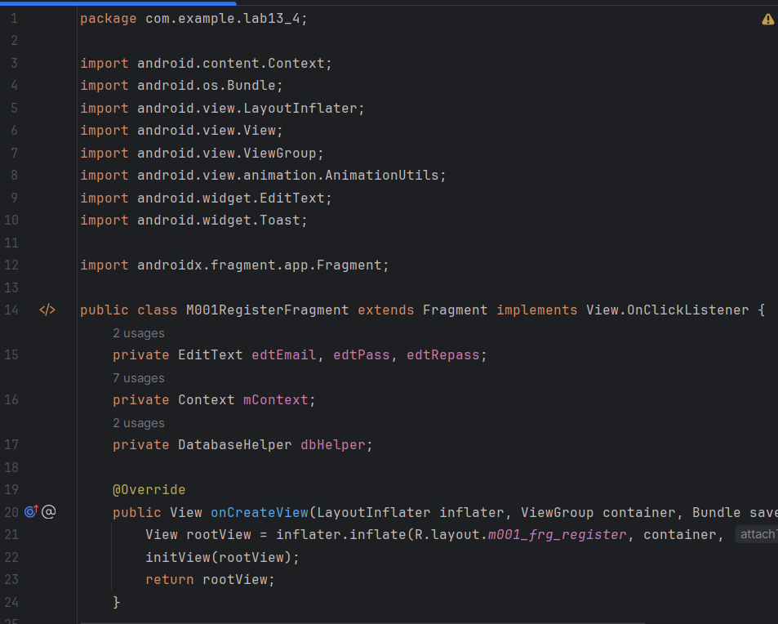

8.3. M002HomeFragment.java

Vị trí: app/src/main/java/com/example/lab13_4/M002HomeFragment.java

Chức năng: Hiển thị email, View Accounts, Logout

private void showAccountsList() {  
 String accountsInfo = accountManager.exportAccountsToString();  
 AlertDialog.Builder builder = new AlertDialog.Builder(mContext);  
 builder.setTitle("Danh sách tài khoản");  
 builder.setMessage(accountsInfo);  
 builder.setPositiveButton("OK", null);  
 builder.show();  
}  
  
private void logout() {  
 String loggedInEmail = dbHelper.getLoggedInUser();  
 if (loggedInEmail != null) {  
 dbHelper.logoutUser(loggedInEmail);  
 prefHelper.clearLoginInfo();  
 Toast.makeText(mContext, "Logged out!", Toast.LENGTH_SHORT).show();  
 ((MainActivity) mContext).gotoLoginScreen();  
 }  
}

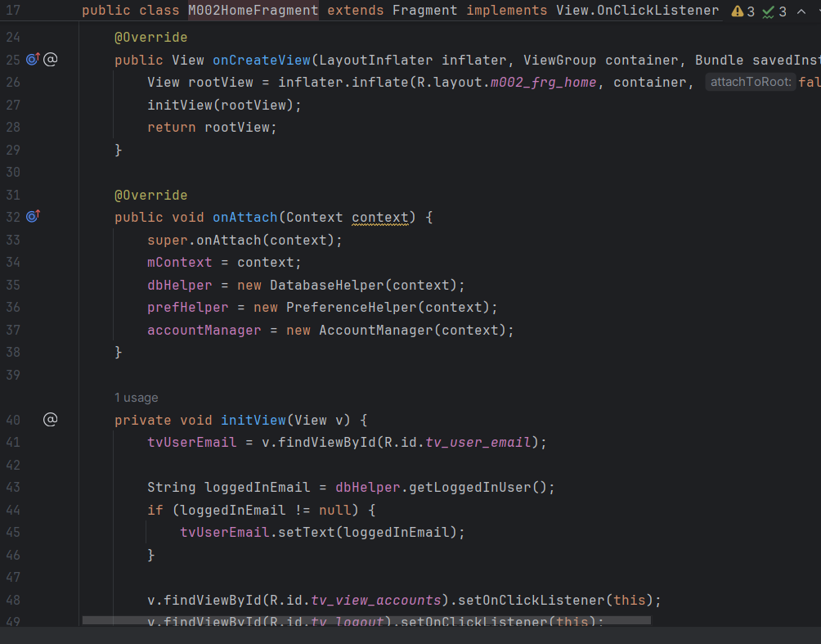

**Bước 9: Cập nhật MainActivity.java**

Vị trí: app/src/main/java/com/example/lab13_4/MainActivity.java

Chức năng:

- Kiểm tra isUserLoggedIn() khi khởi động

- Nếu có user đang login → gotoHomeScreen()

- Nếu không → gotoLoginScreen()

- Các method điều hướng: gotoLoginScreen(), gotoRegisterScreen(), gotoHomeScreen()